The system shall display navigation bar. In Home Page, slider, latest articles & additional articles must be visible.

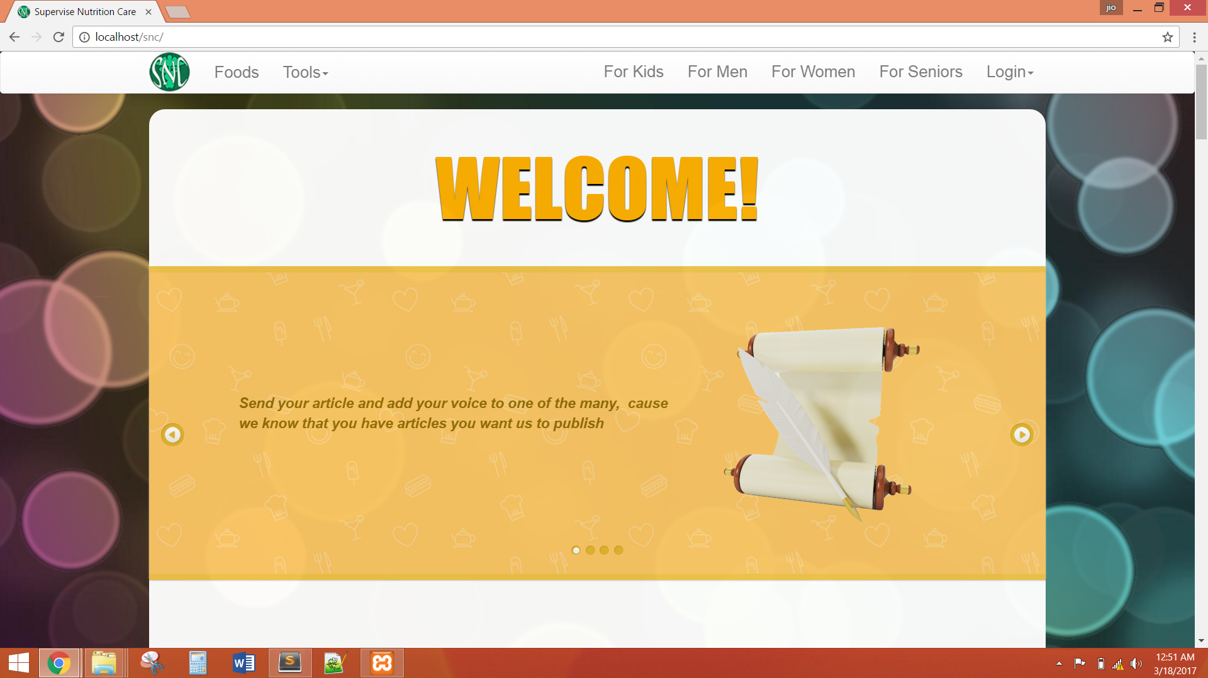



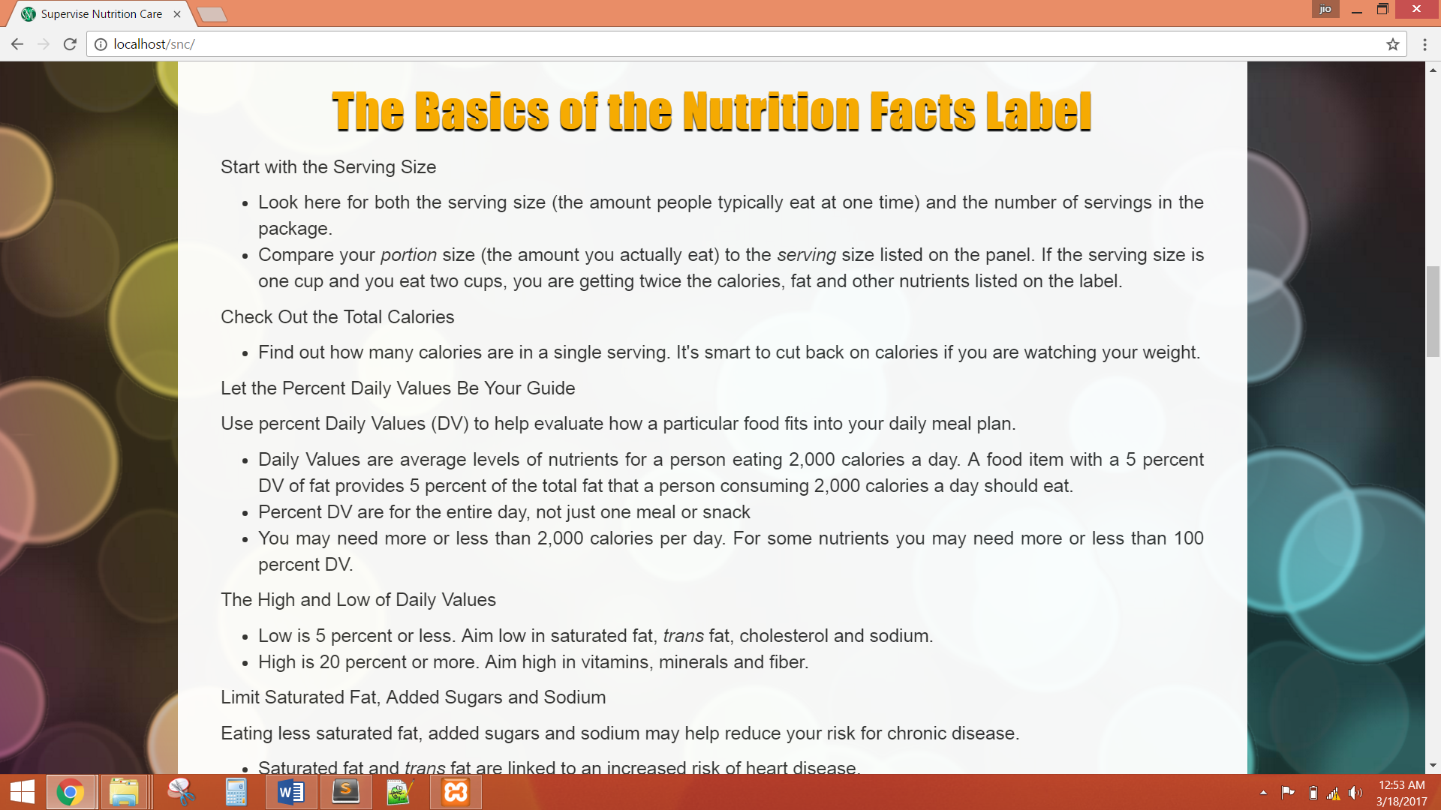

The system shall display the food table that must display basic nutrition facts of specific food.

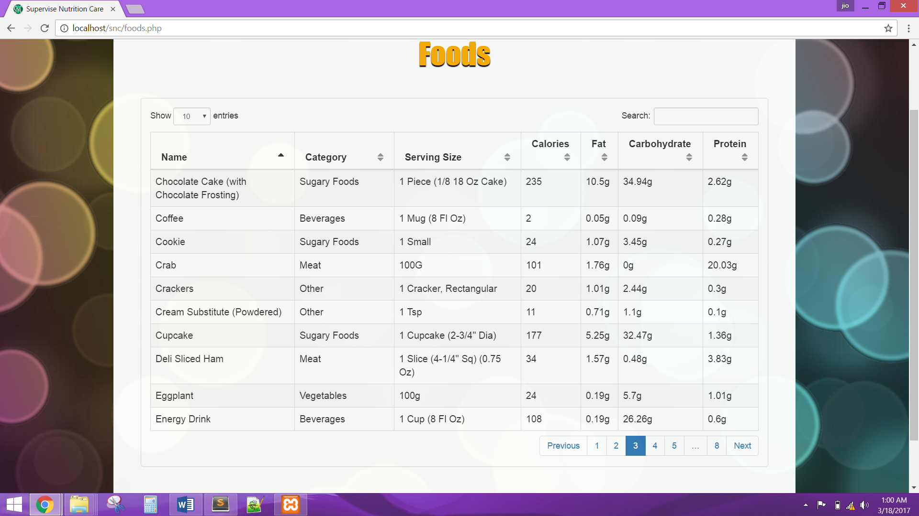

The system shall display the detailed nutrition facts of a specific food by clicking a row in Food Table. Changing the “Amount per Serving” shall automatically calculate the new values of nutrition facts.

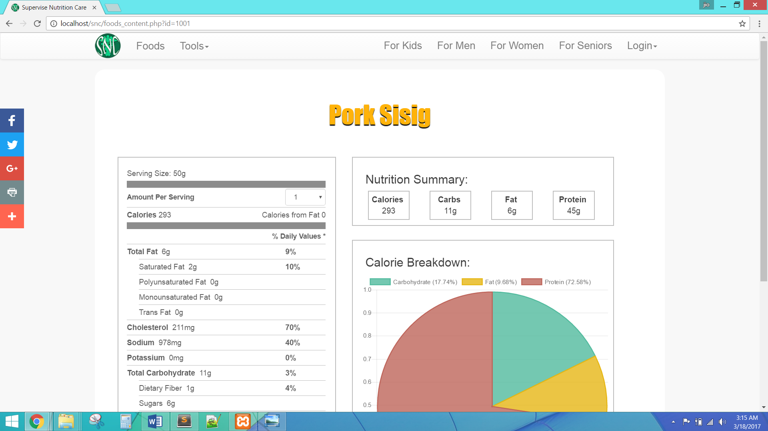

The Food Table shall also be searchable, navigate page, and able to change the number of entries to be shown.

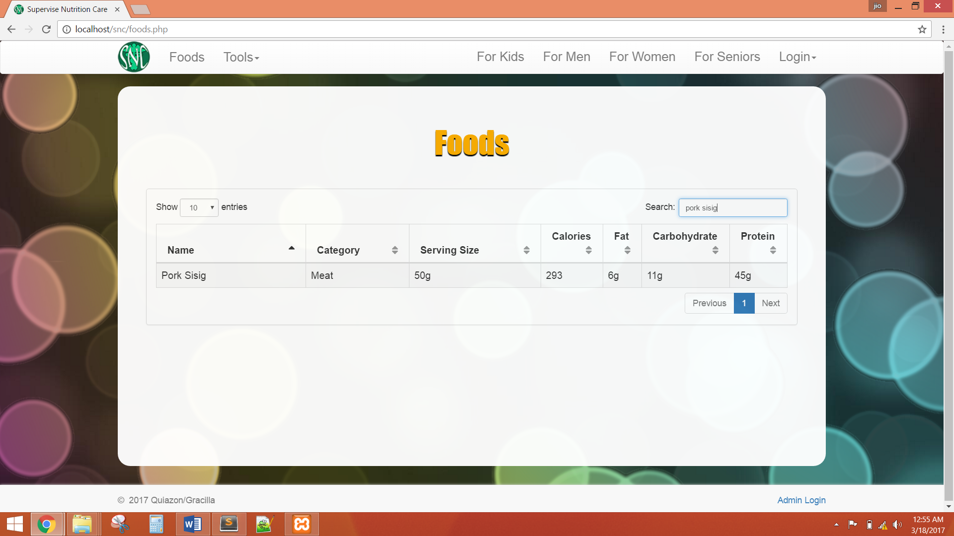

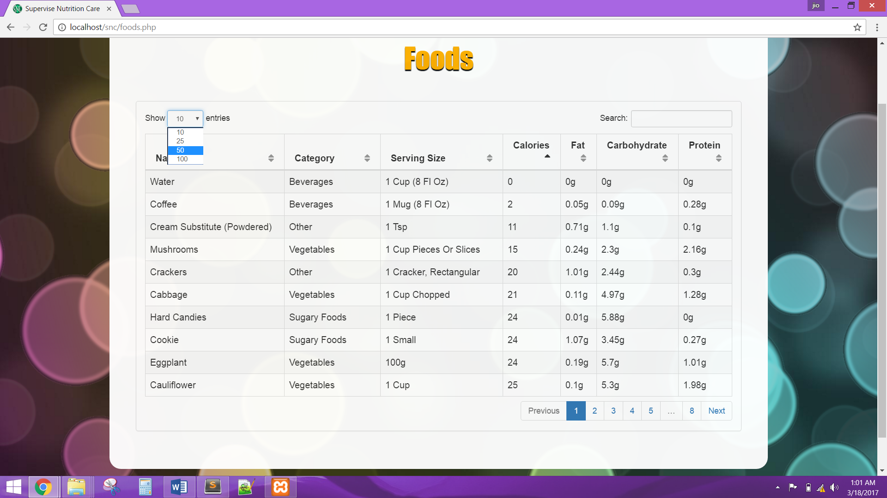

The system shall be able to calculate the Body Mass Index. The Calculator shall only accept numerical data entry, valid height and valid weight. The page shall also display an additional information about BMI and the formulas used.

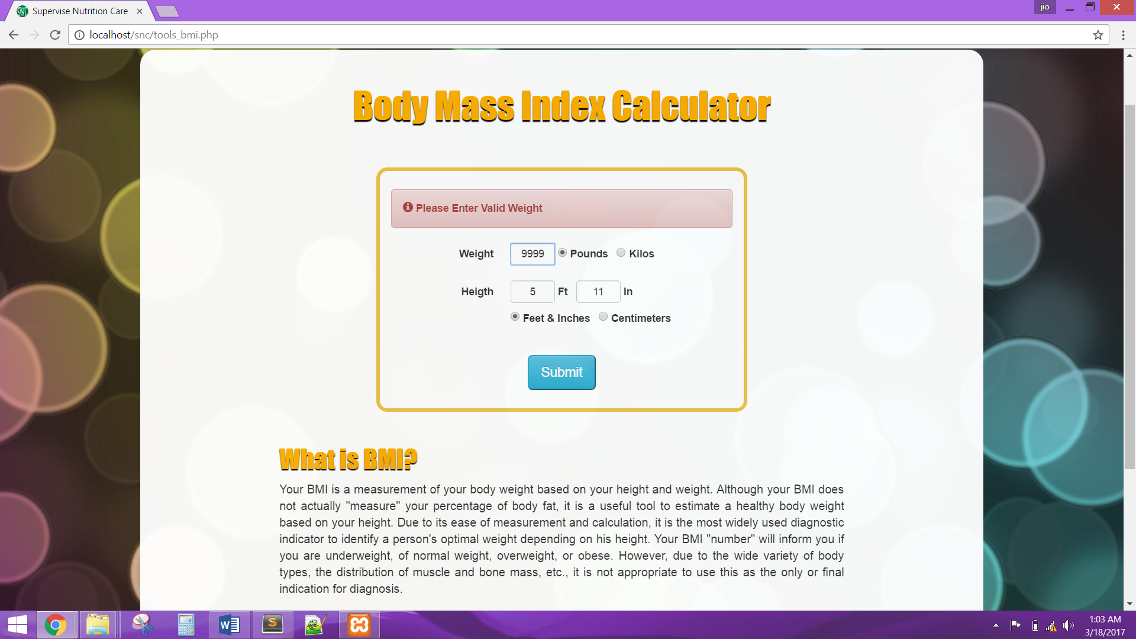

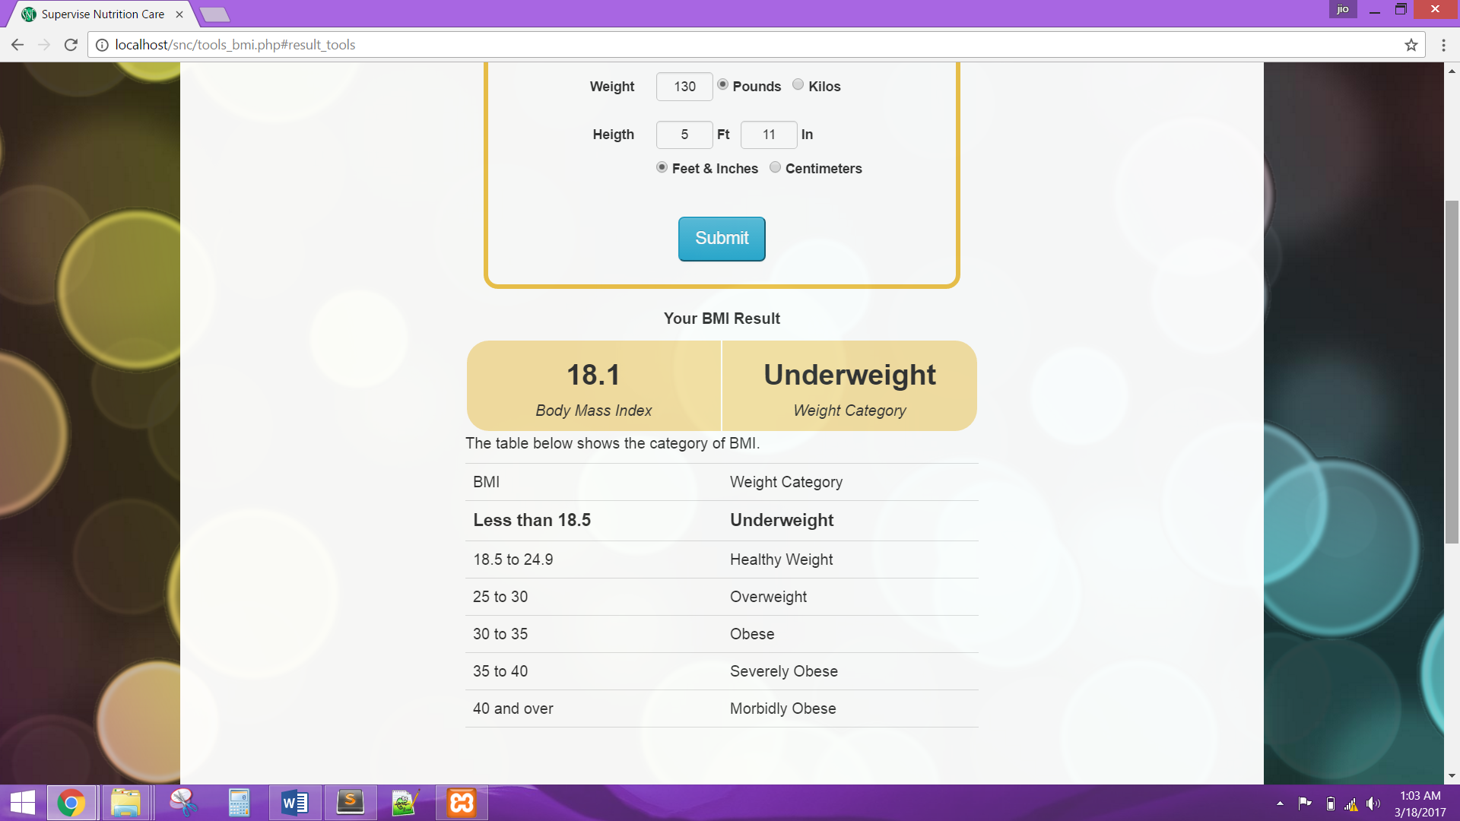

The system shall be able to calculate the Ideal Body Weight. The Calculator shall only accept numerical data entry and valid height. The page shall also display the formulas used.

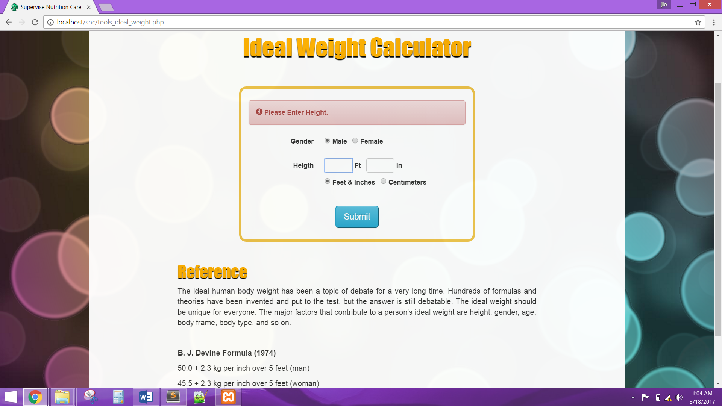

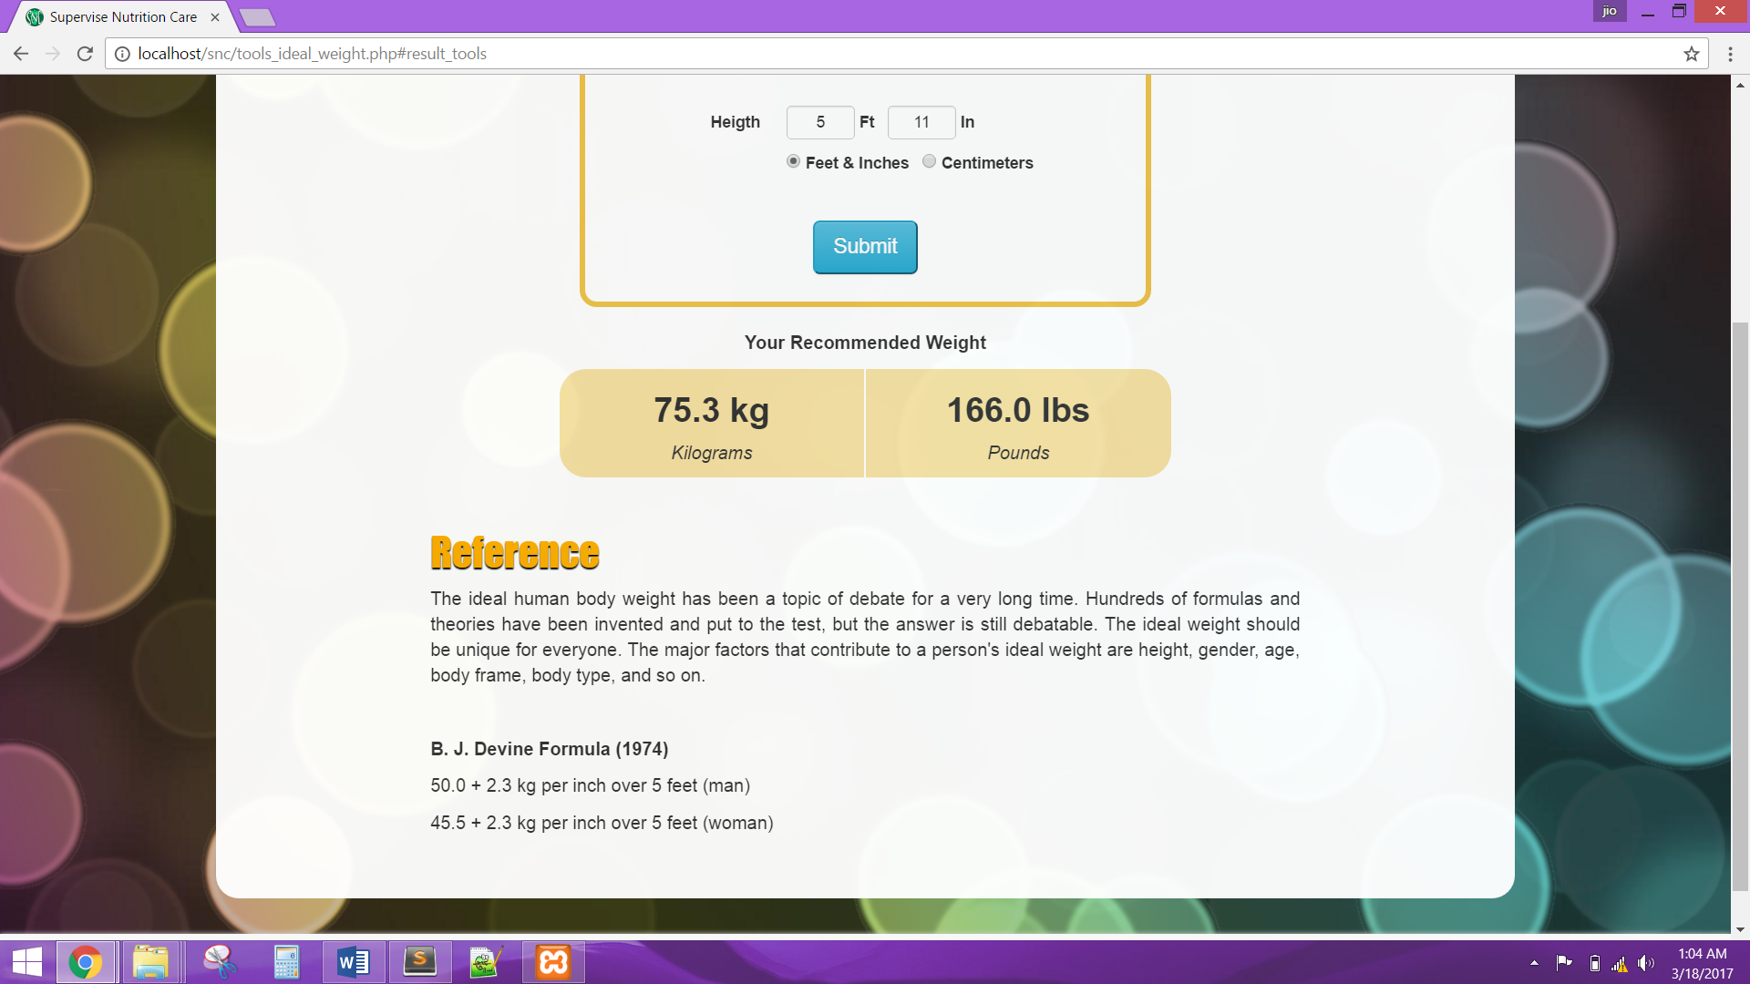

The system shall be able to calculate the Daily Calorie Needs. The Calculator shall only accept numerical data entry, valid age, valid height and valid weight. The page shall also display an additional information about Daily Calorie Needs and the formulas used.

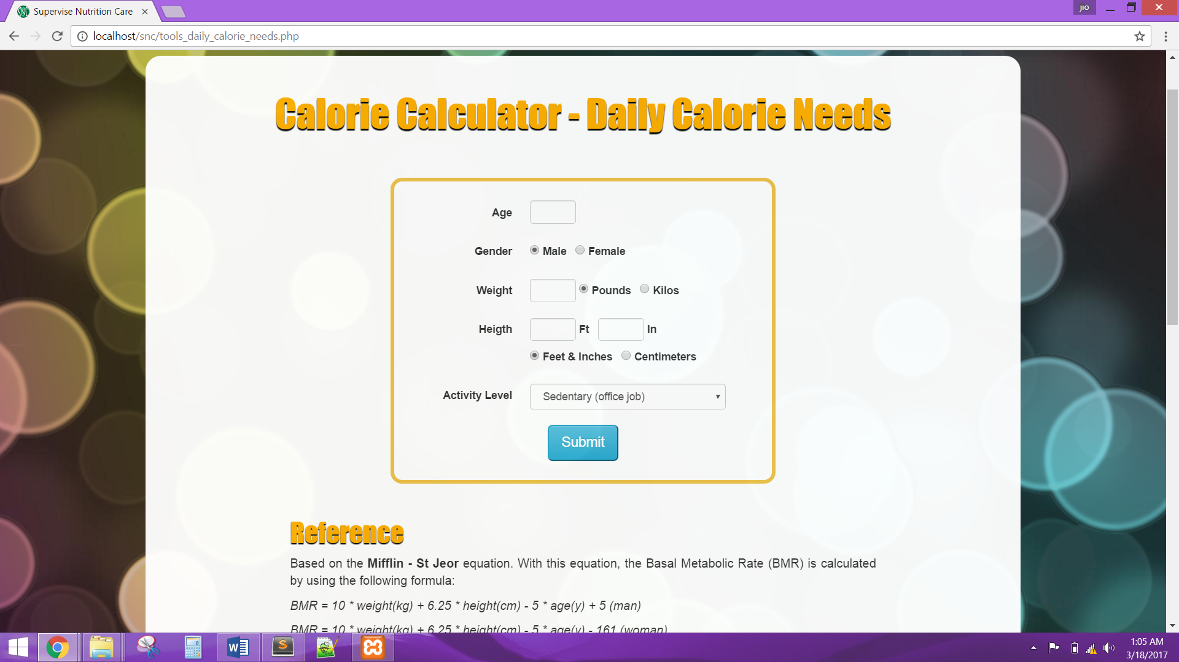

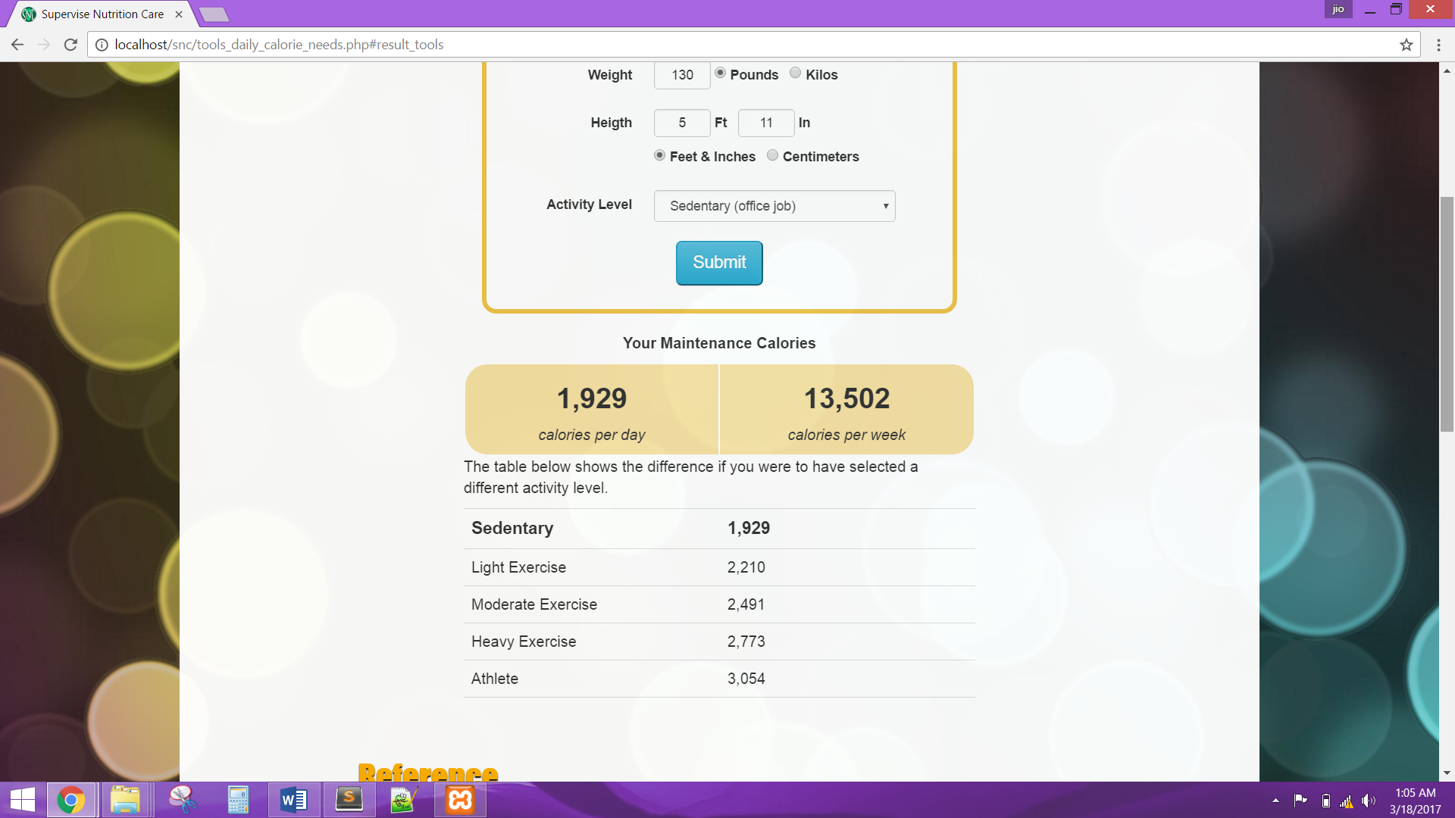

The system shall be able to exhibit articles and the user shall be able to choose a category through navigation bar. The articles must be searchable, navigate page, and able to change the number of entries to be shown.

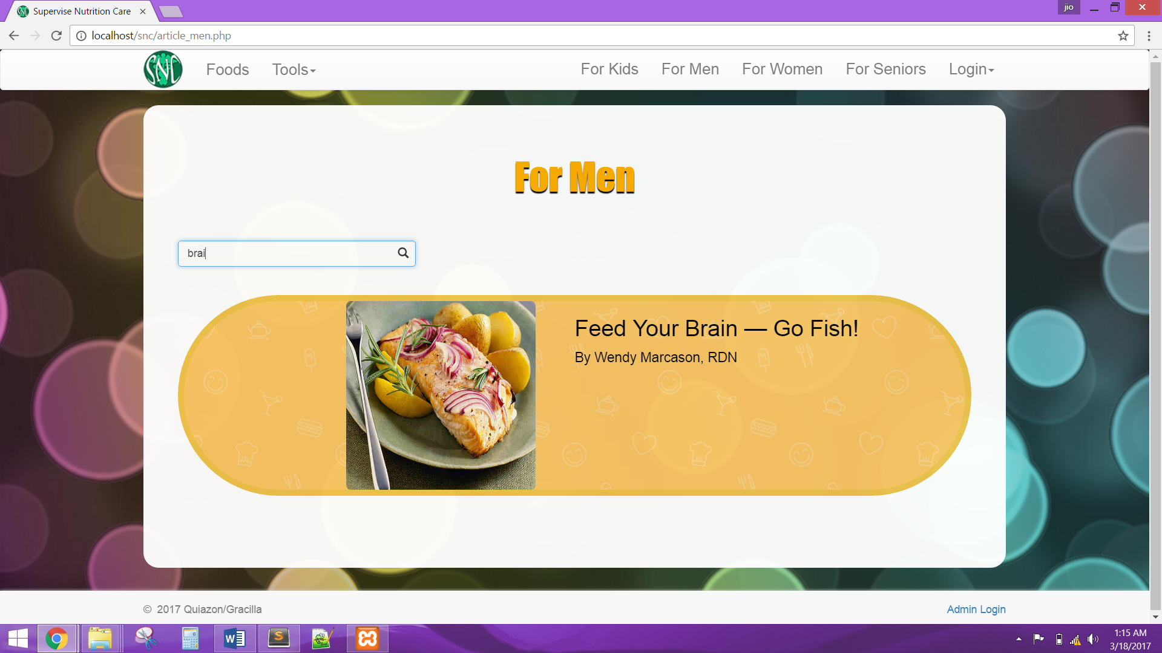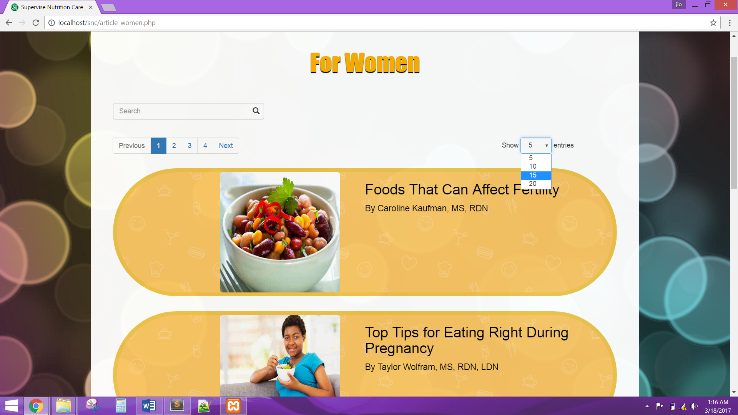

The system shall display the article content. The user shall be able to share the article with social plugins, and print the article.



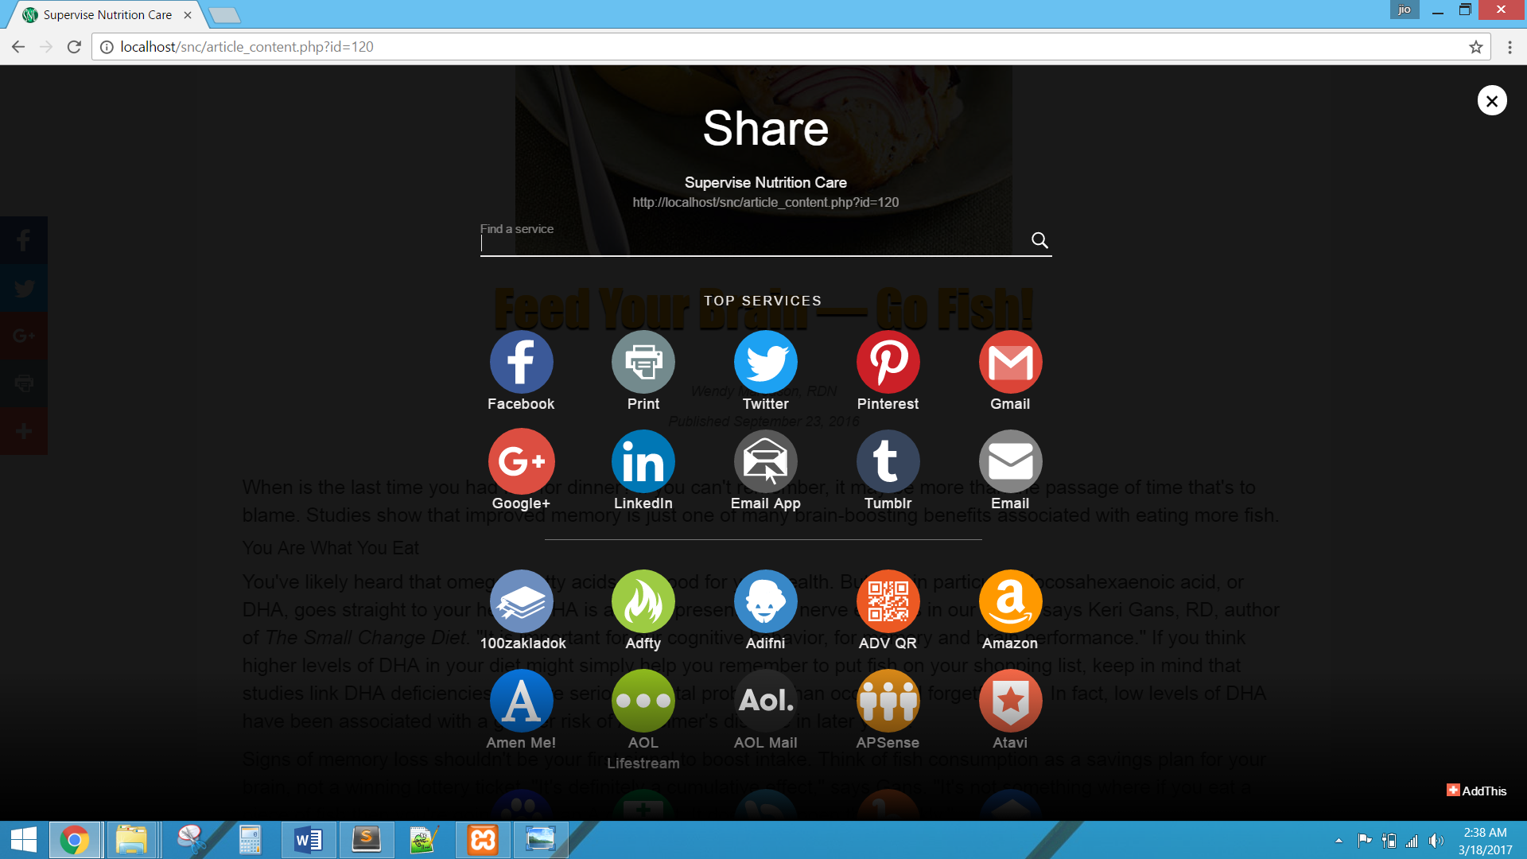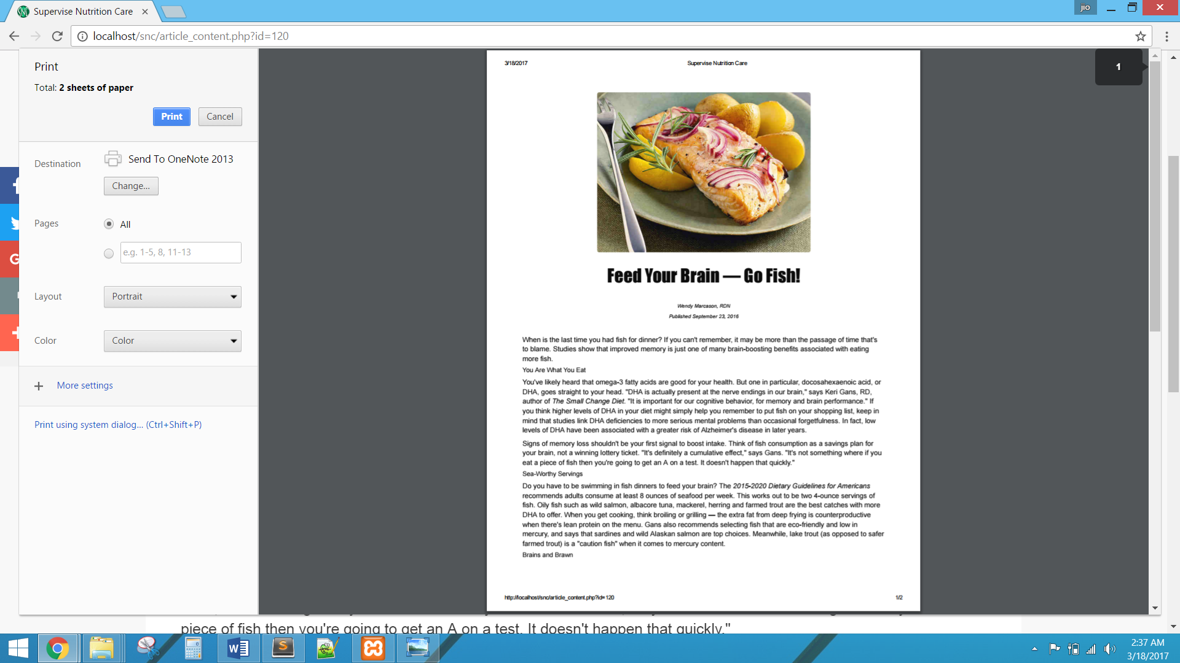

The system shall allow user to login as writer in navigation bar. The login form must have validation rule. The system must disable the login for 10 minutes after three consecutive unsuccessful login attempts.

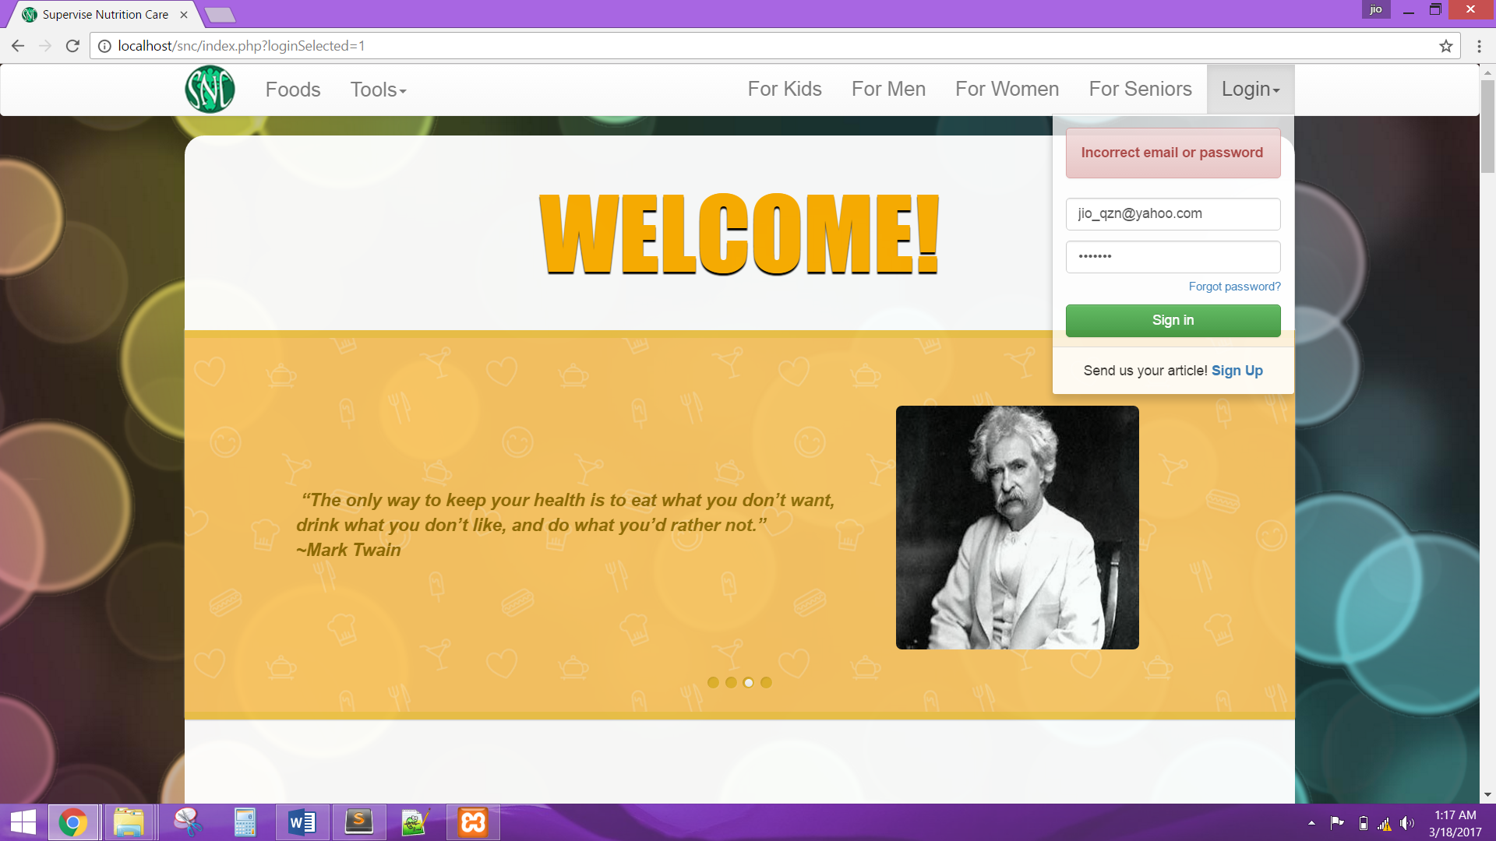

The user shall be able to register and must have a validation rule.

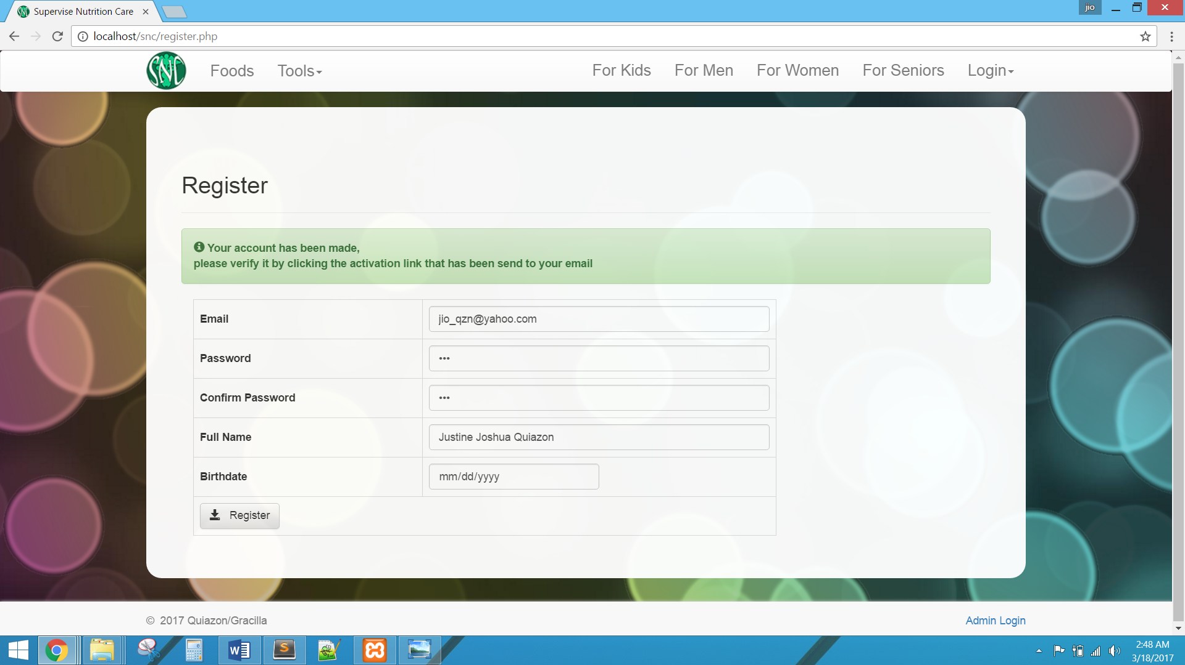

The user shall be able to activate account by clicking the link in the email.

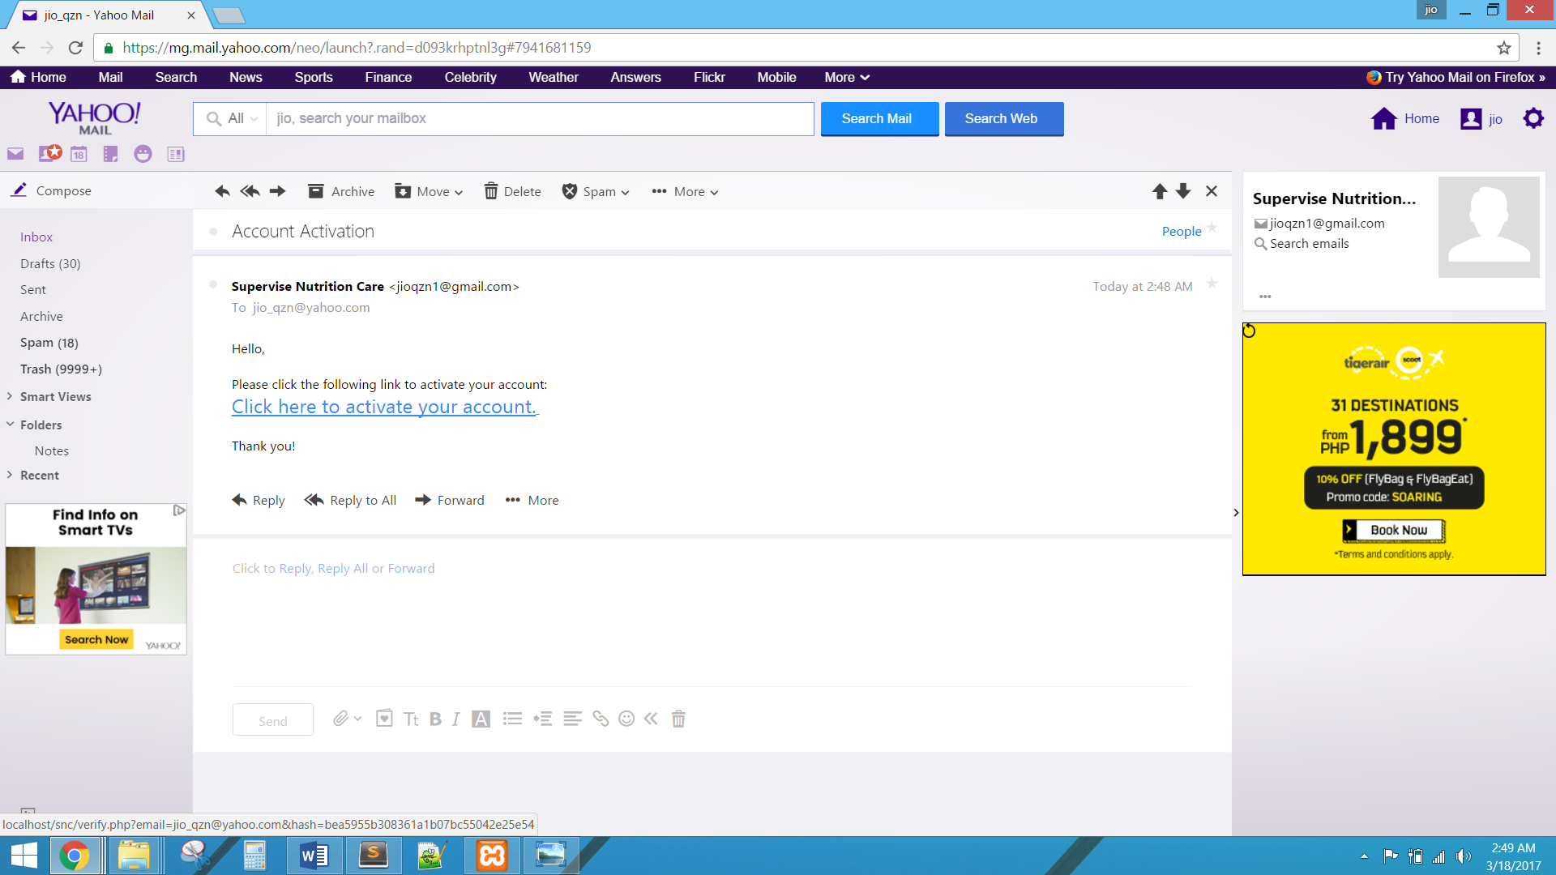

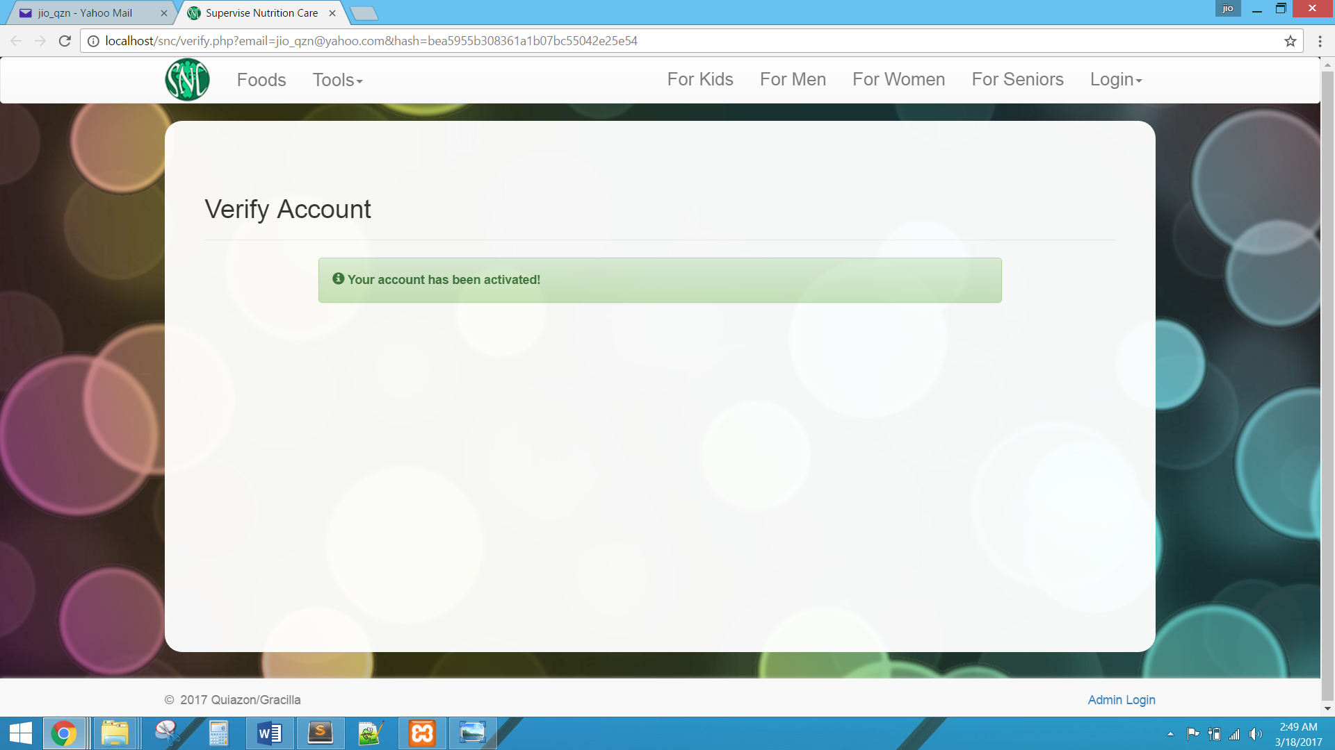

The user shall be able to reset password through email address associated with the account.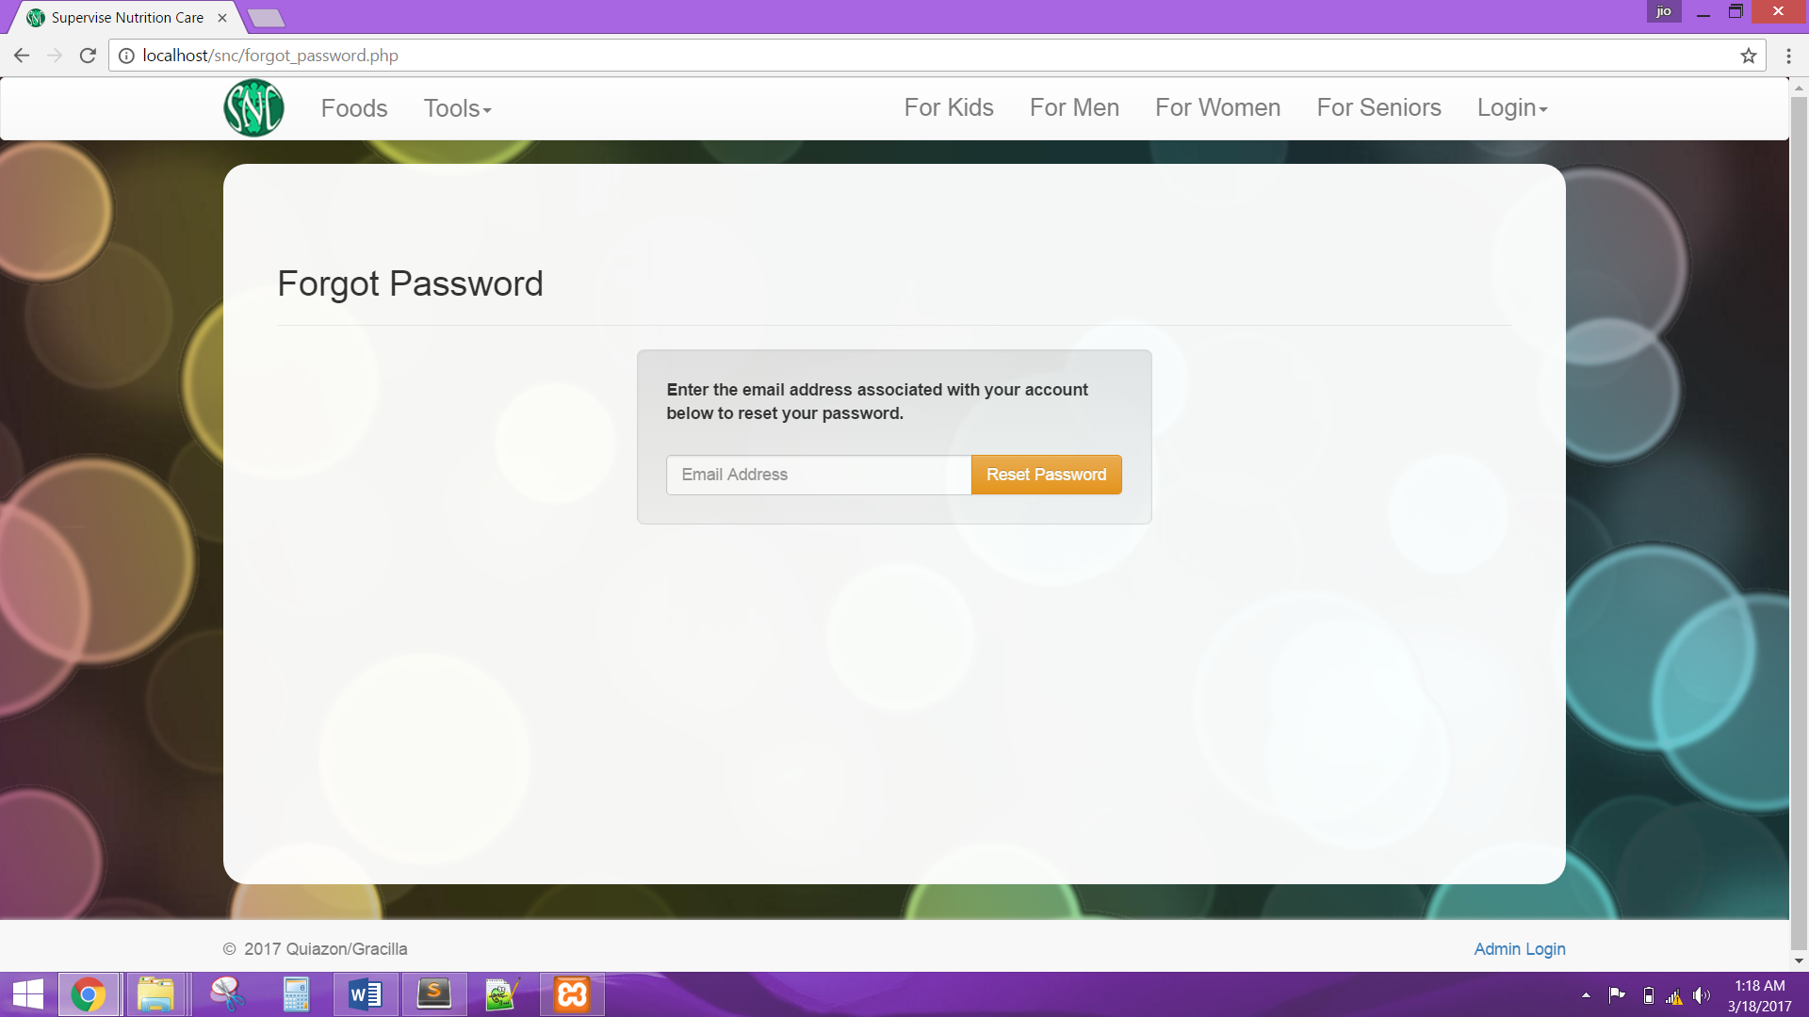

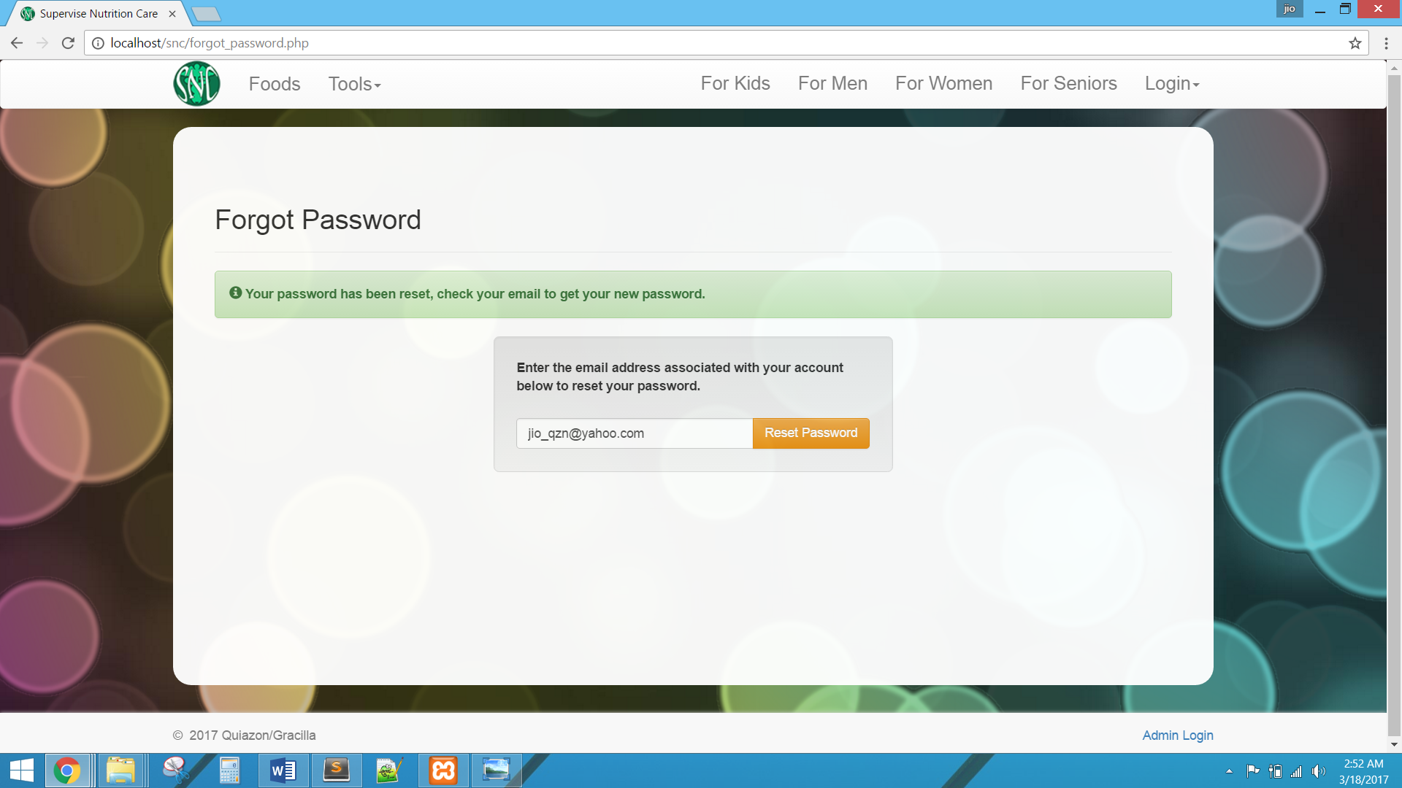

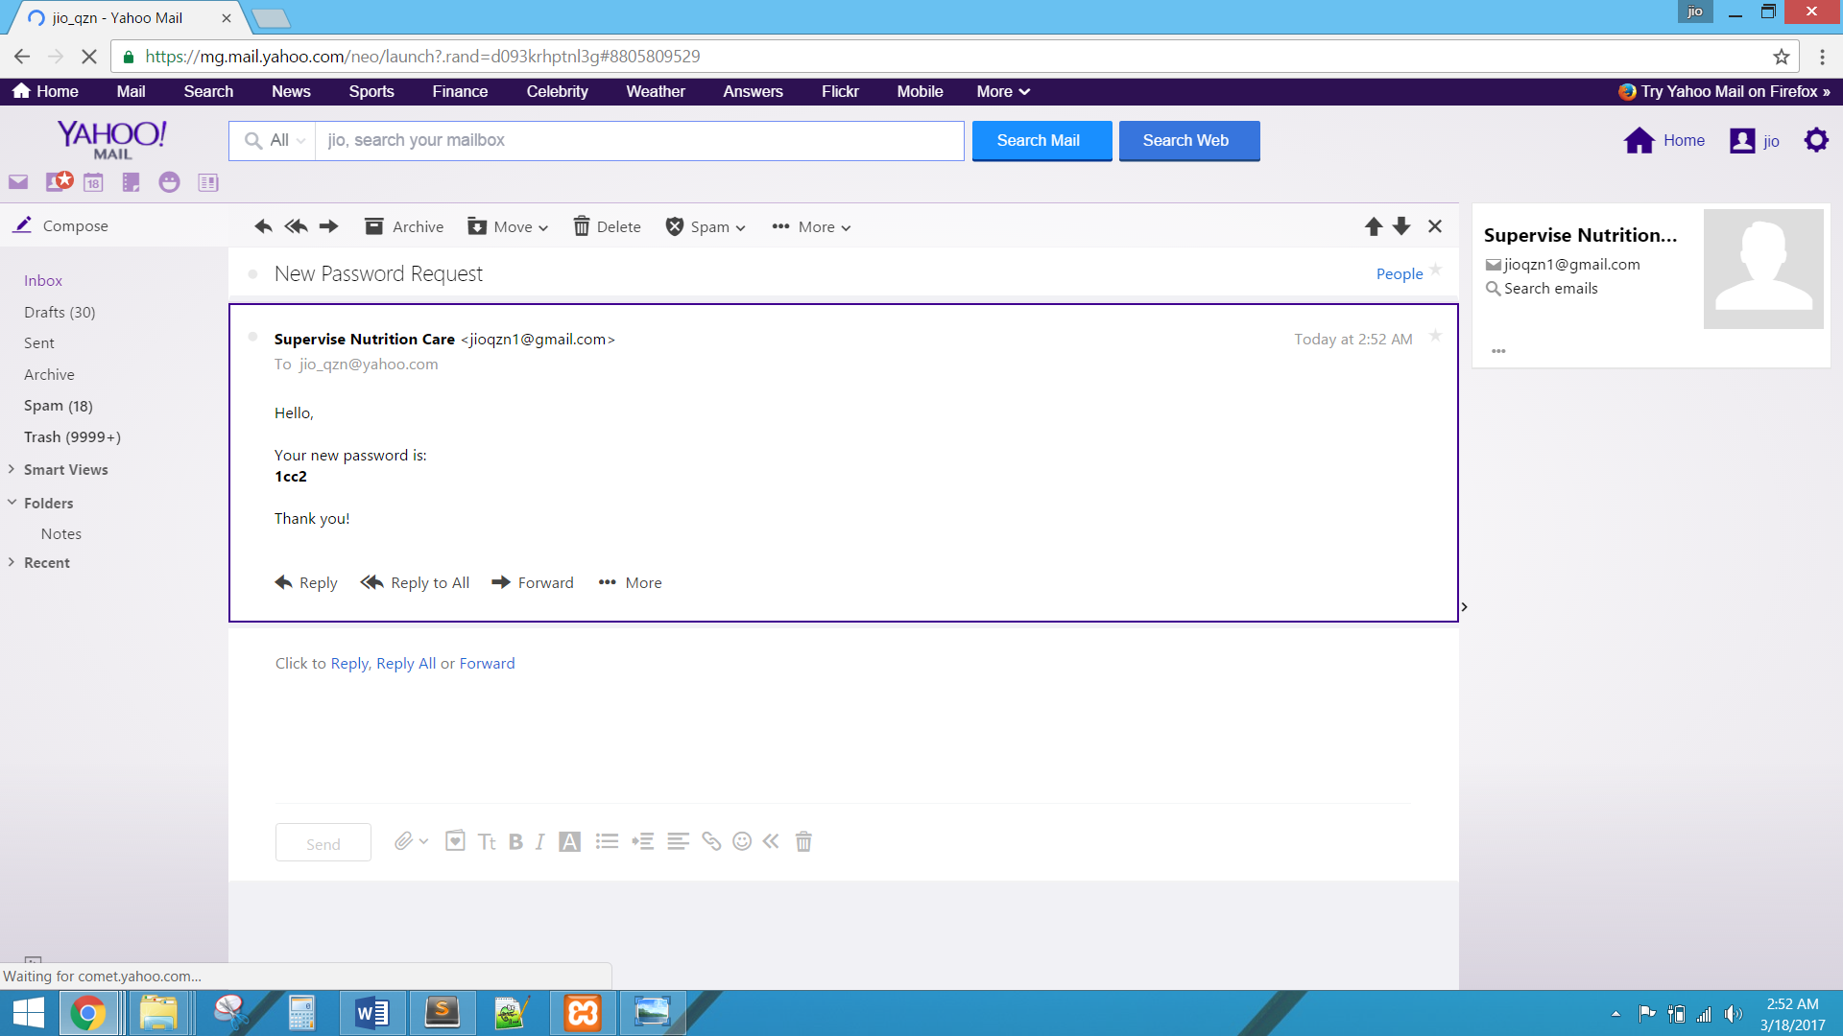

The system shall display the Writer account after a successful login. The system shall also be display real time notifications.

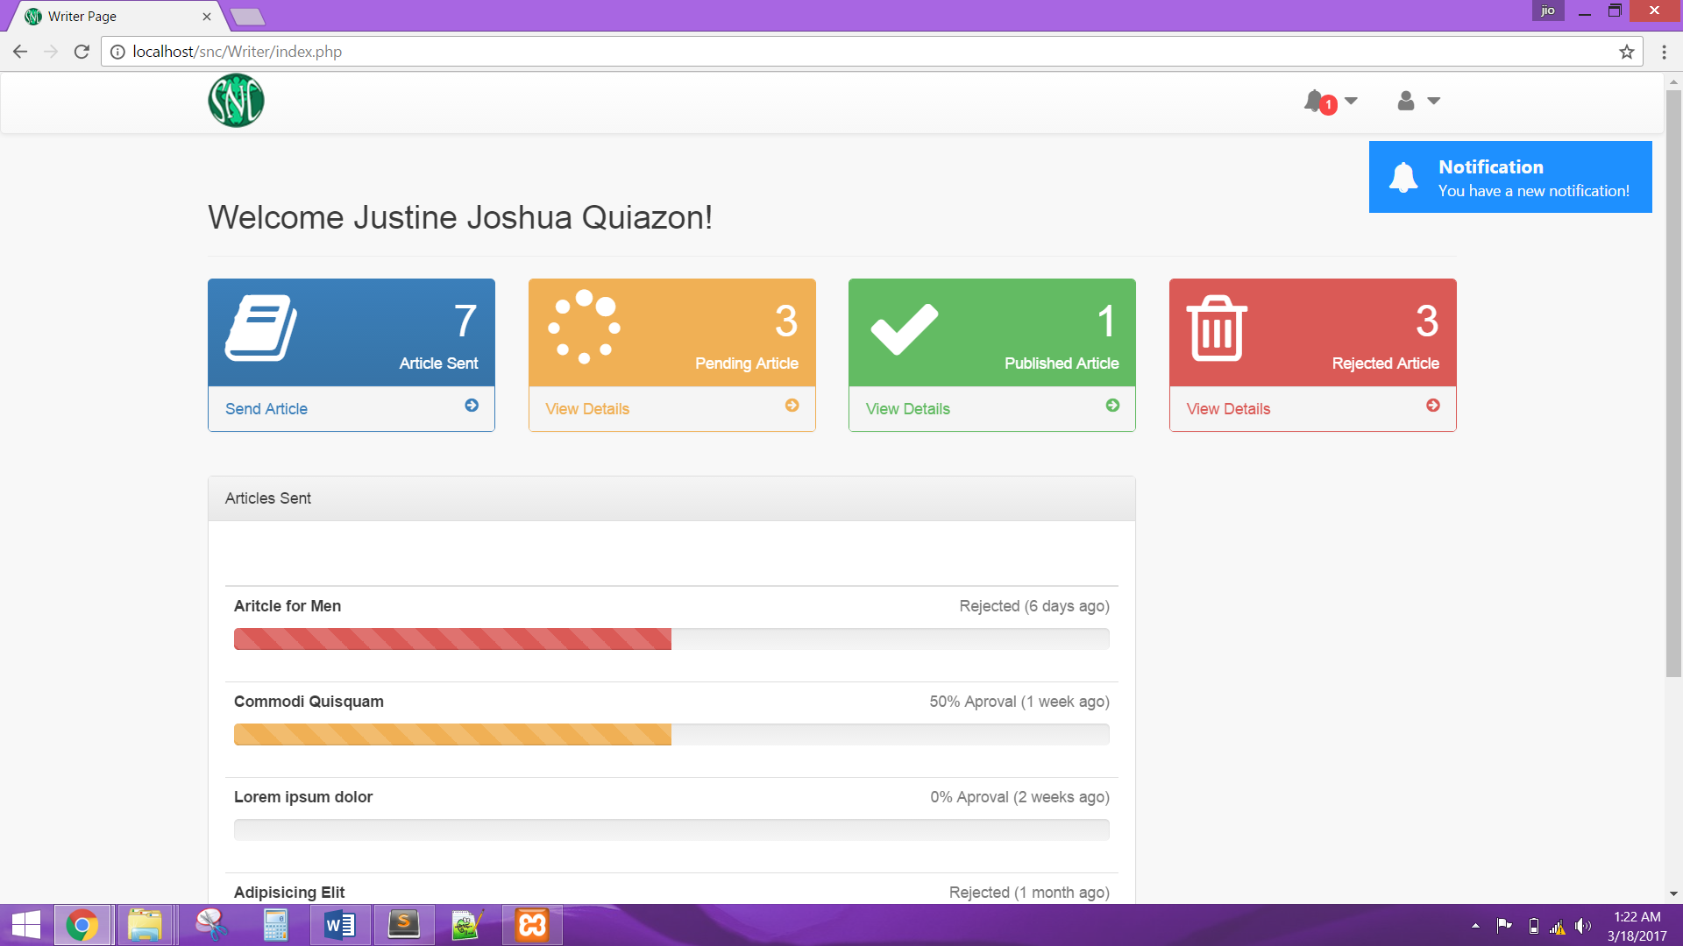

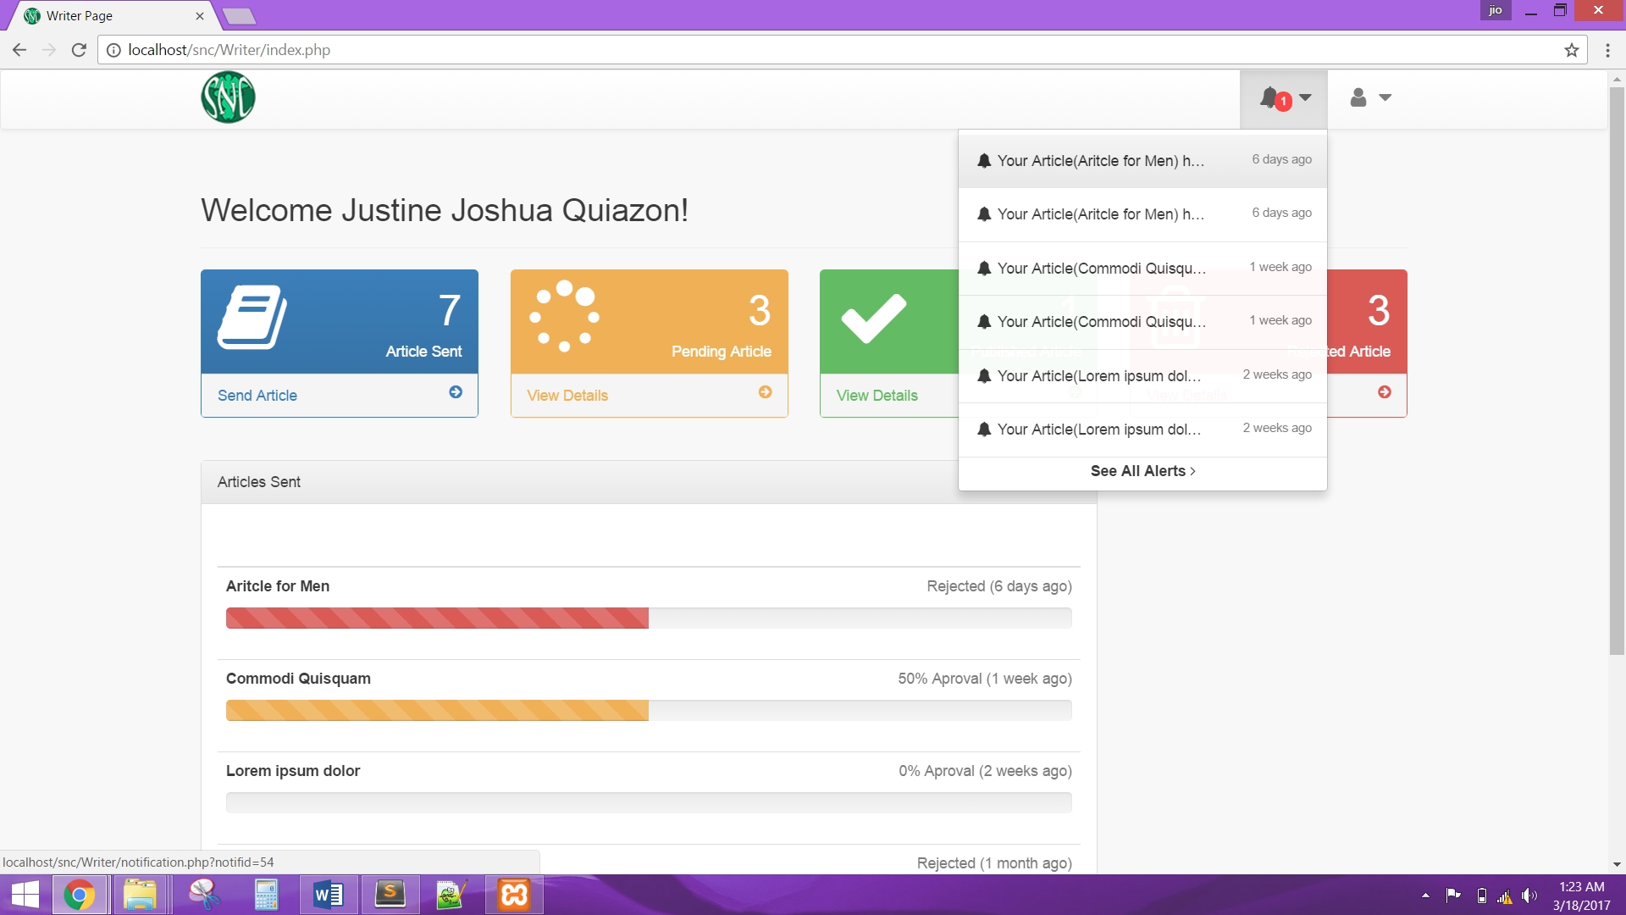

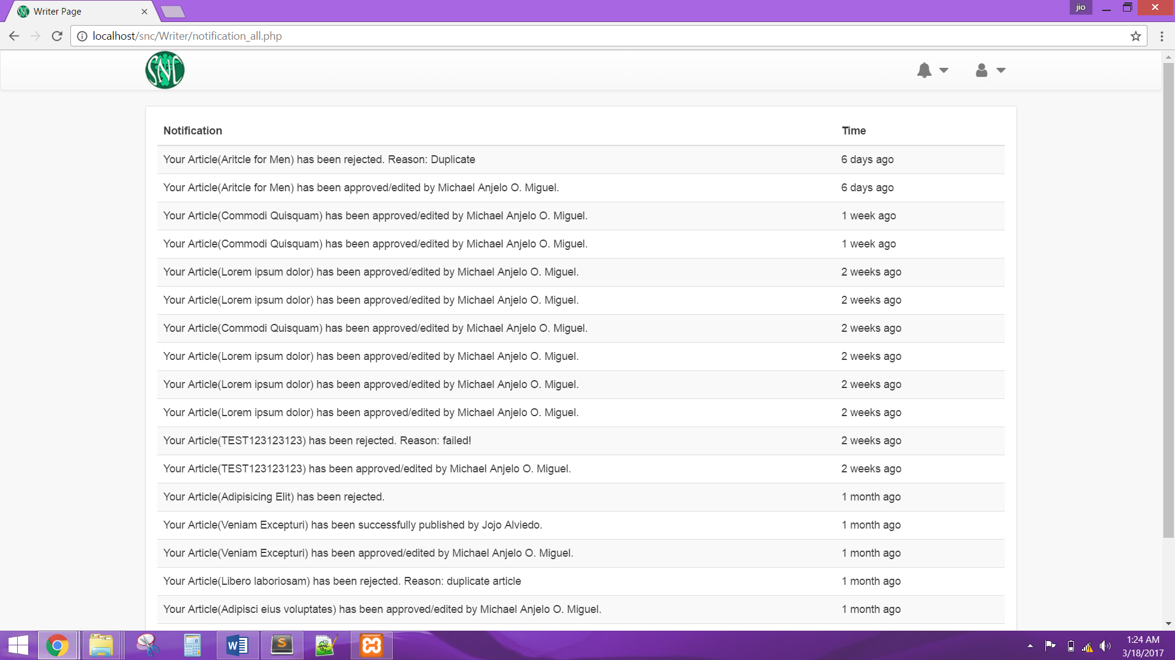

The system shall allow the Writer to manage account by updating profile, or changing password.

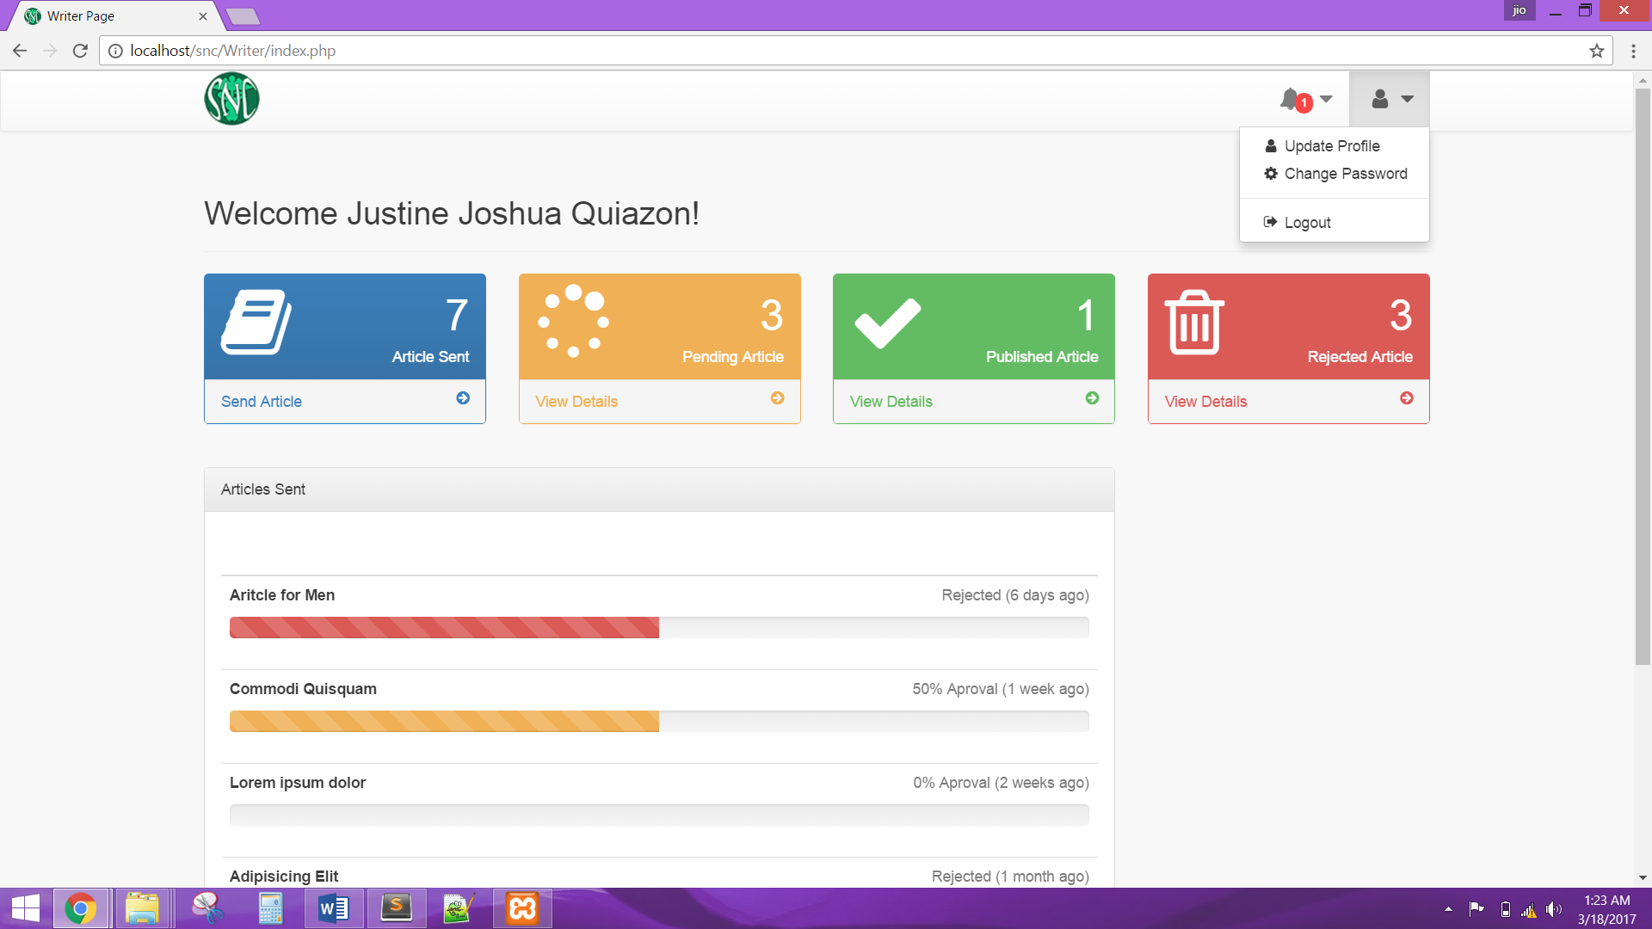

The system shall allow the Writer to view all articles sent.

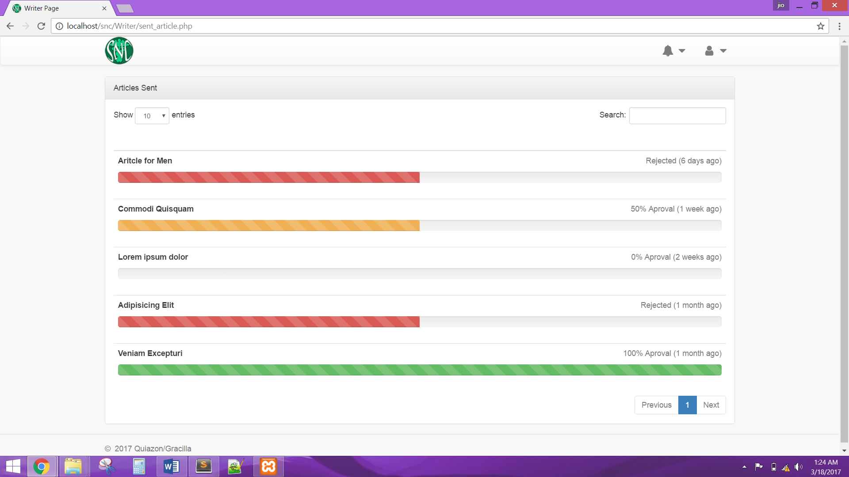

The system shall allow the Writer to send article and must have a validation rule.

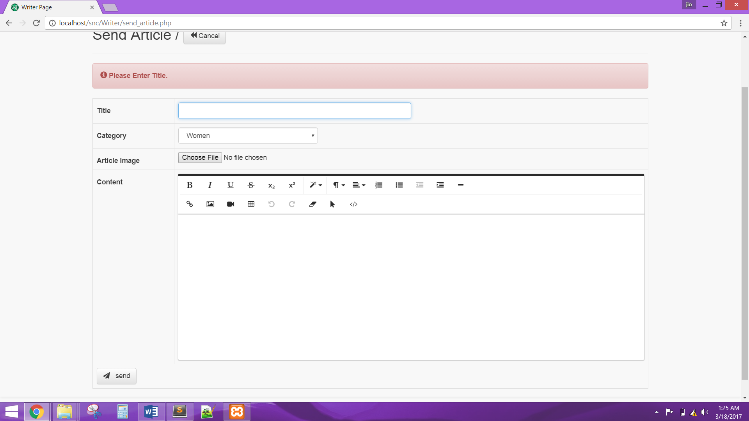

The system shall allow the Writer to view current pending articles that has been sent.

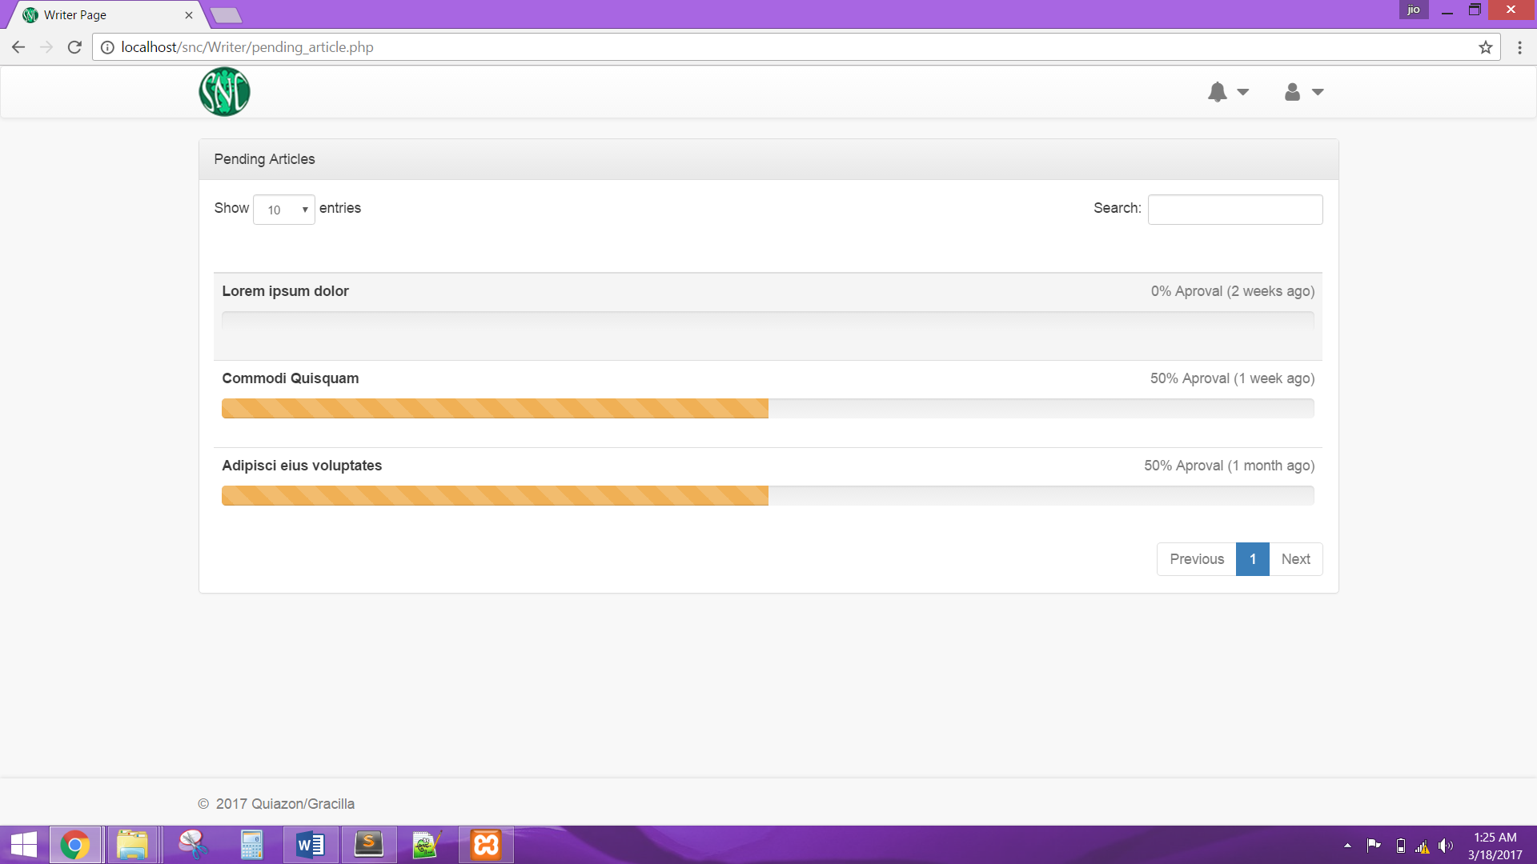

The system shall allow the Writer to view all articles that have been successfully published.

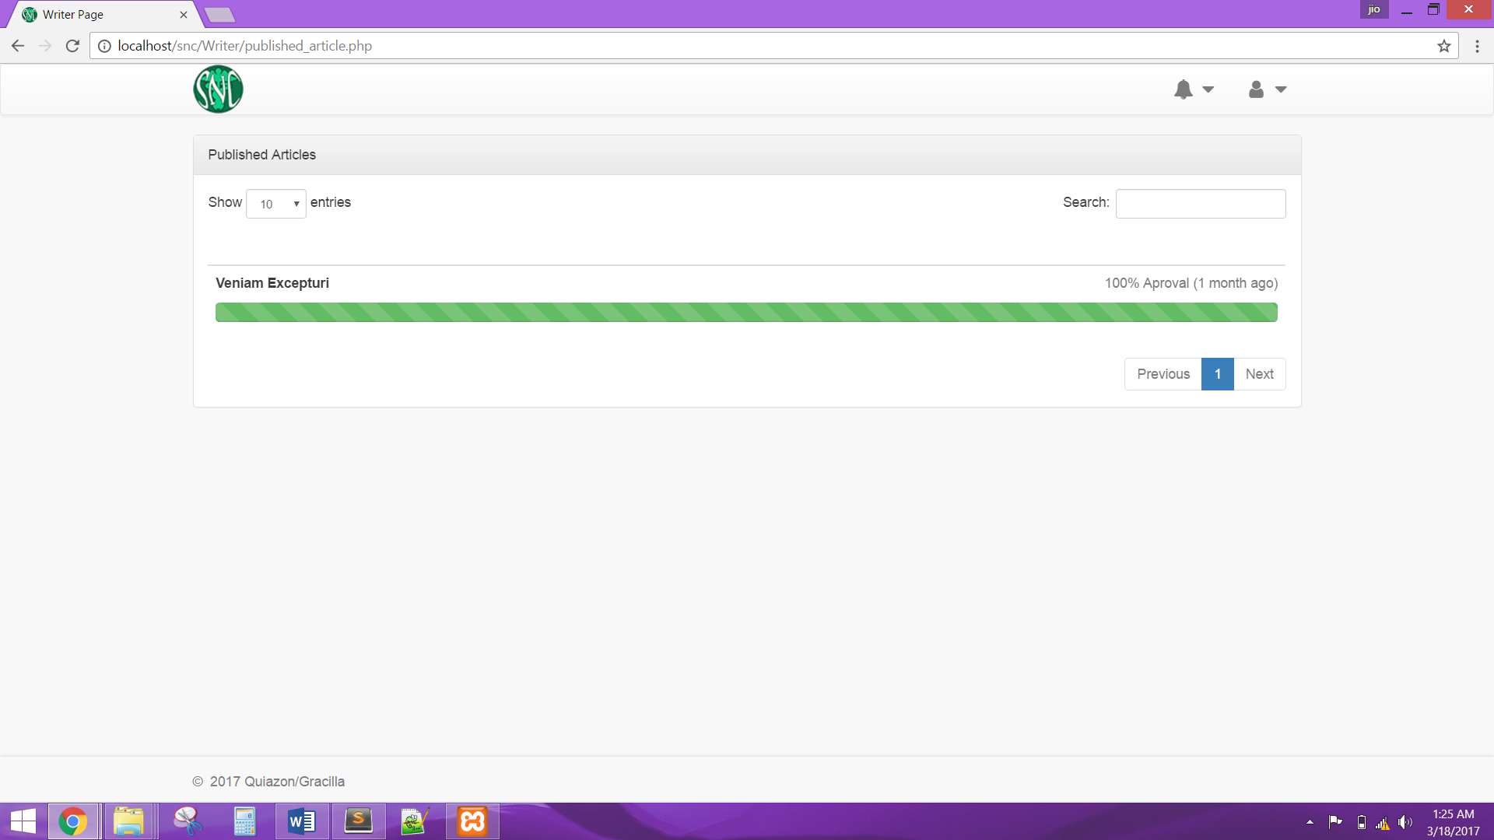

The system shall allow the Writer to view all articles that have been rejected by Editor or Publisher.

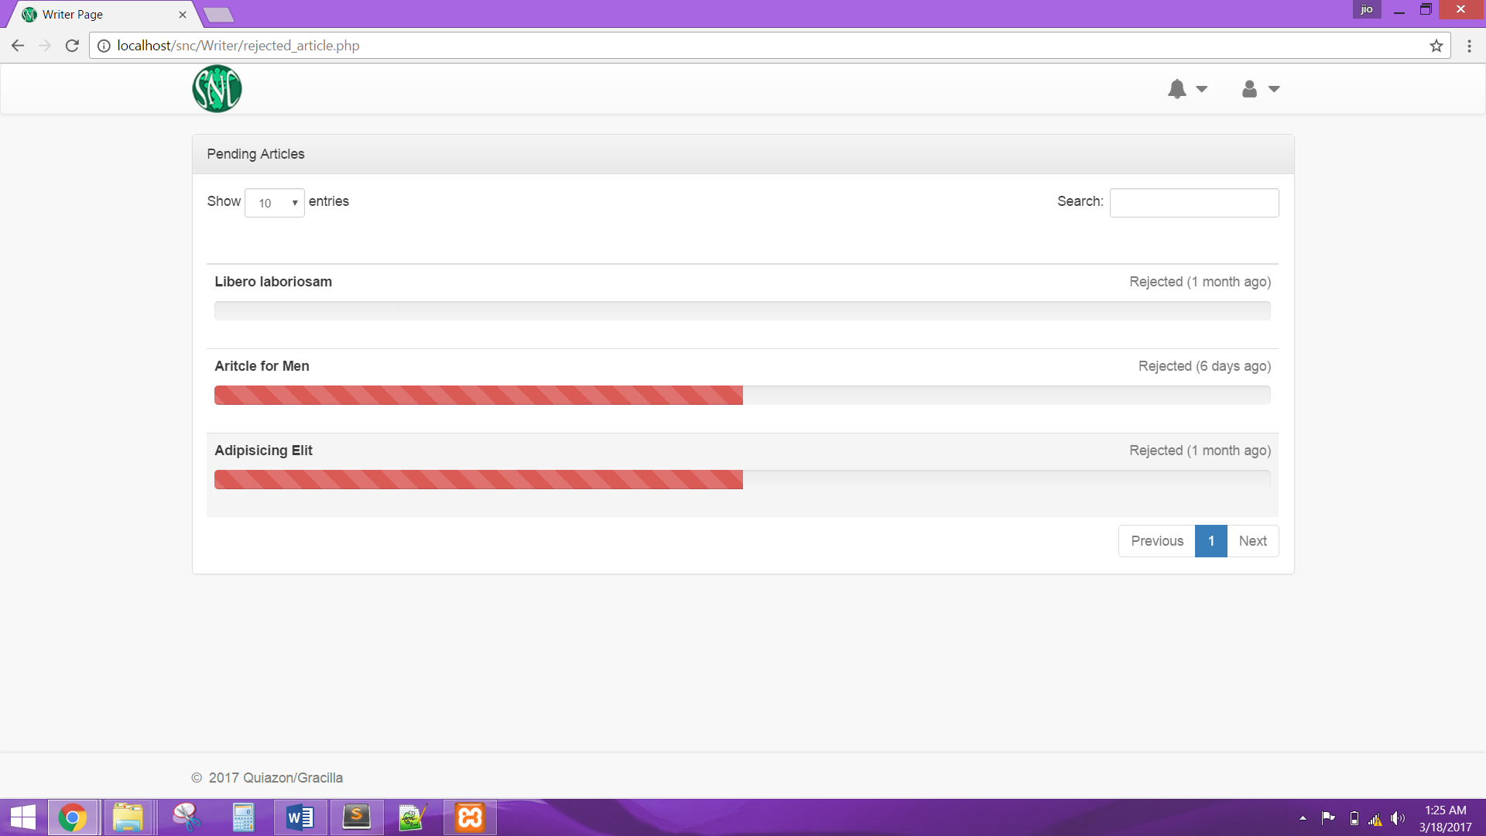

The system shall display the Editor account after a successful login. The system shall allow the Editor to manage account by updating profile, or changing password.

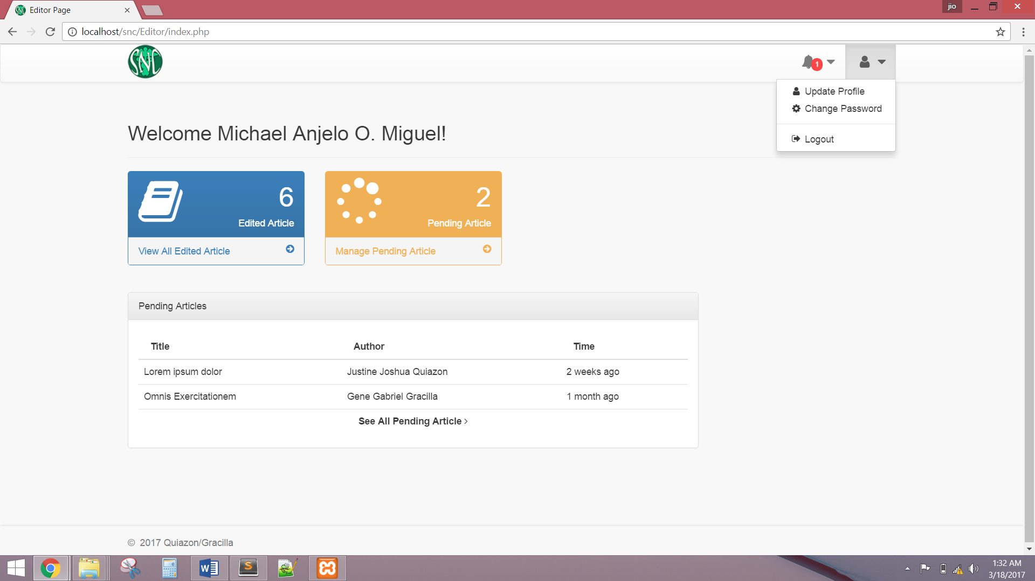

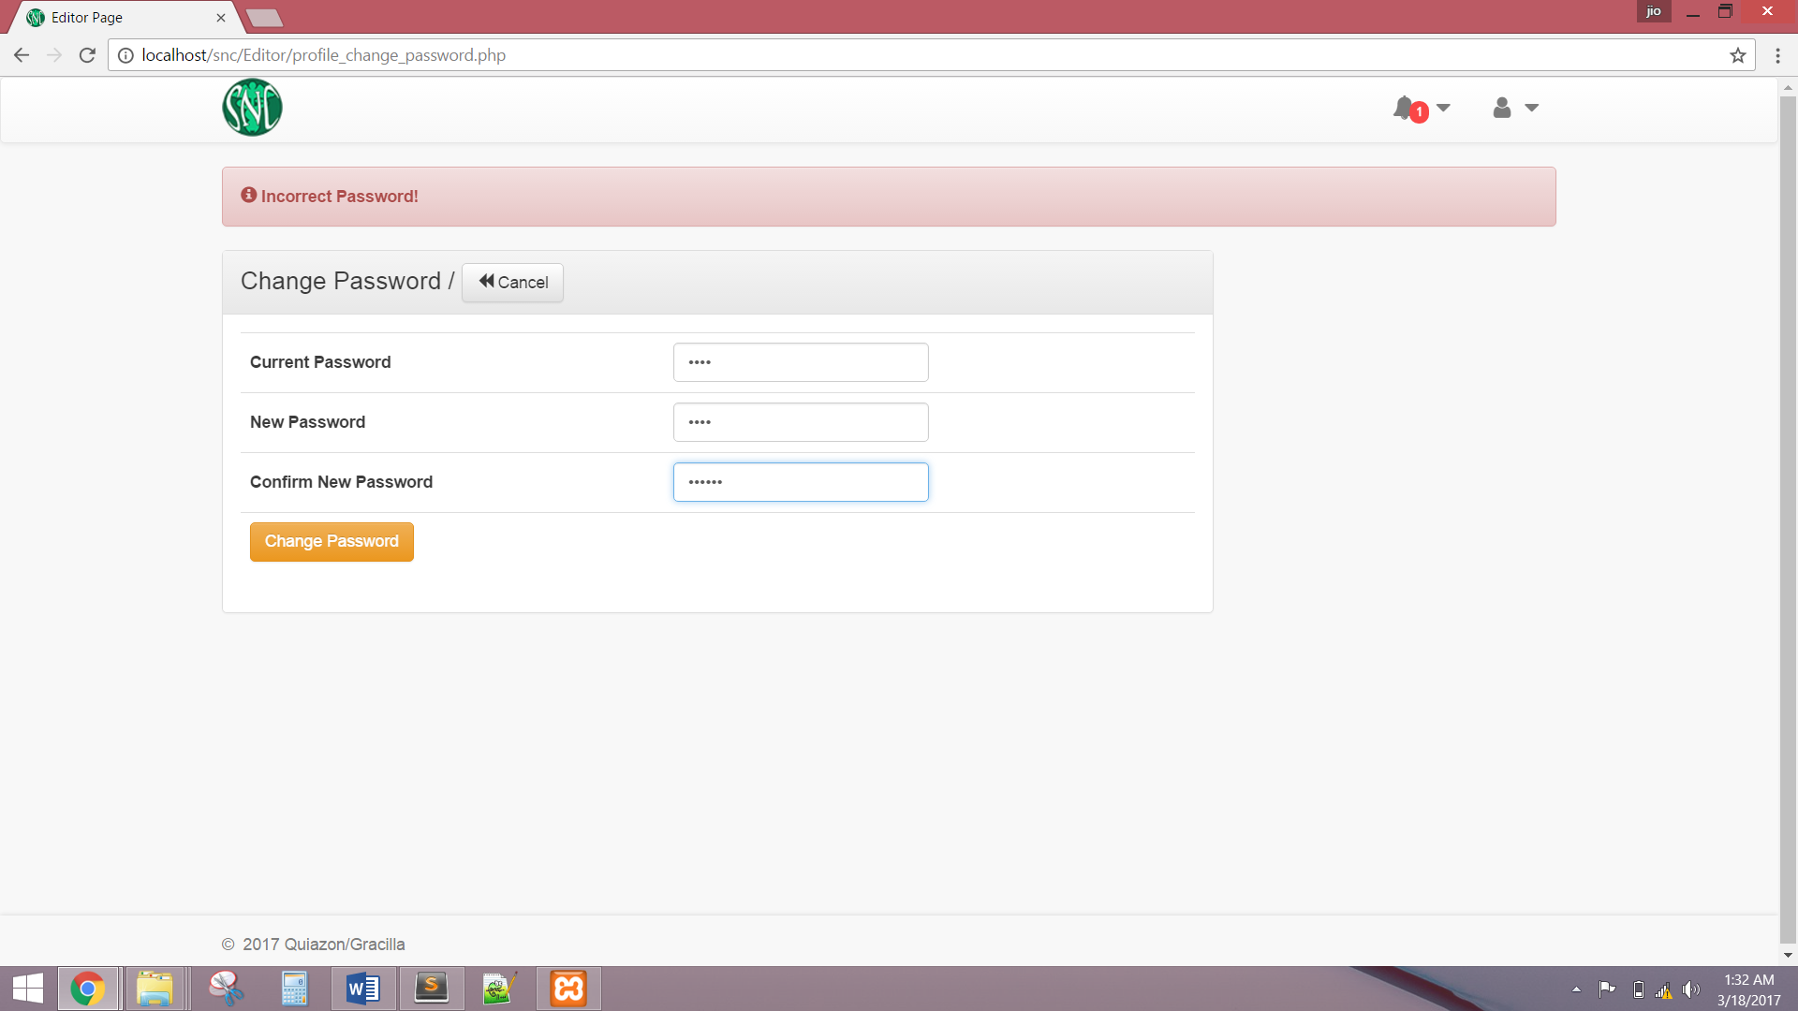

The system shall allow Editor to view all notifications.

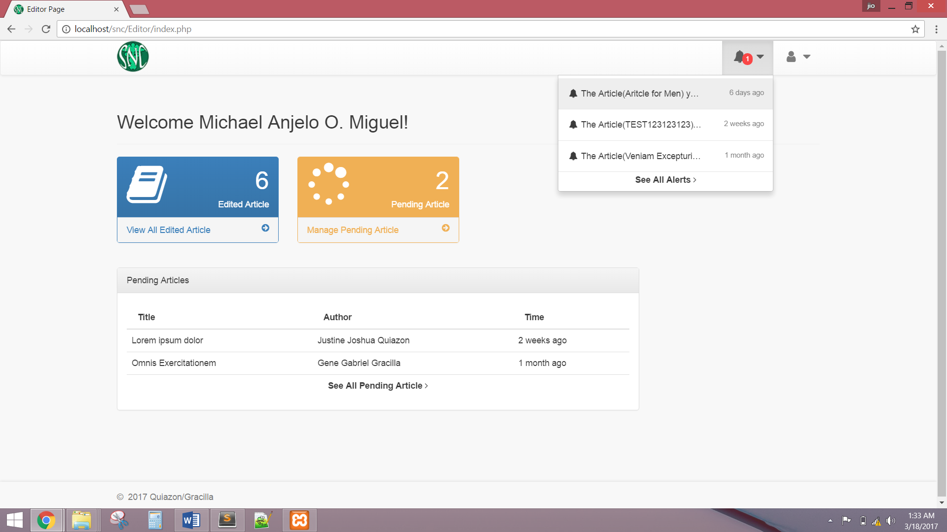

The system shall allow Editor to view all articles sent by Writers.

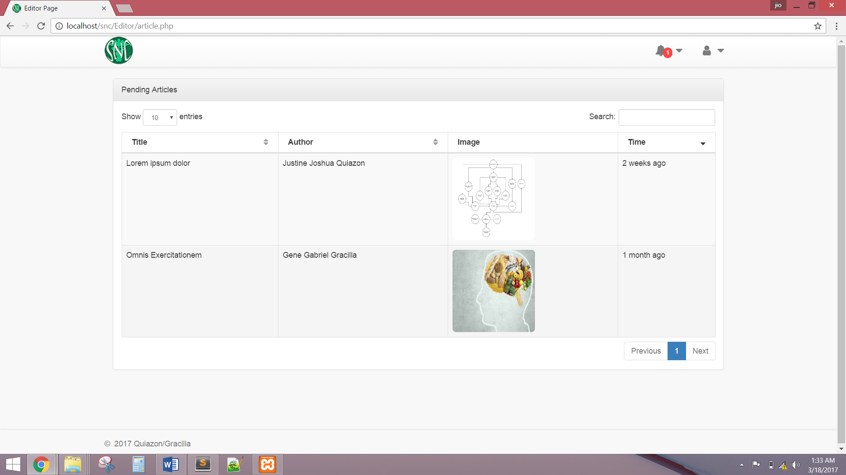

The system shall allow Editor to edit, and accept or reject an article.

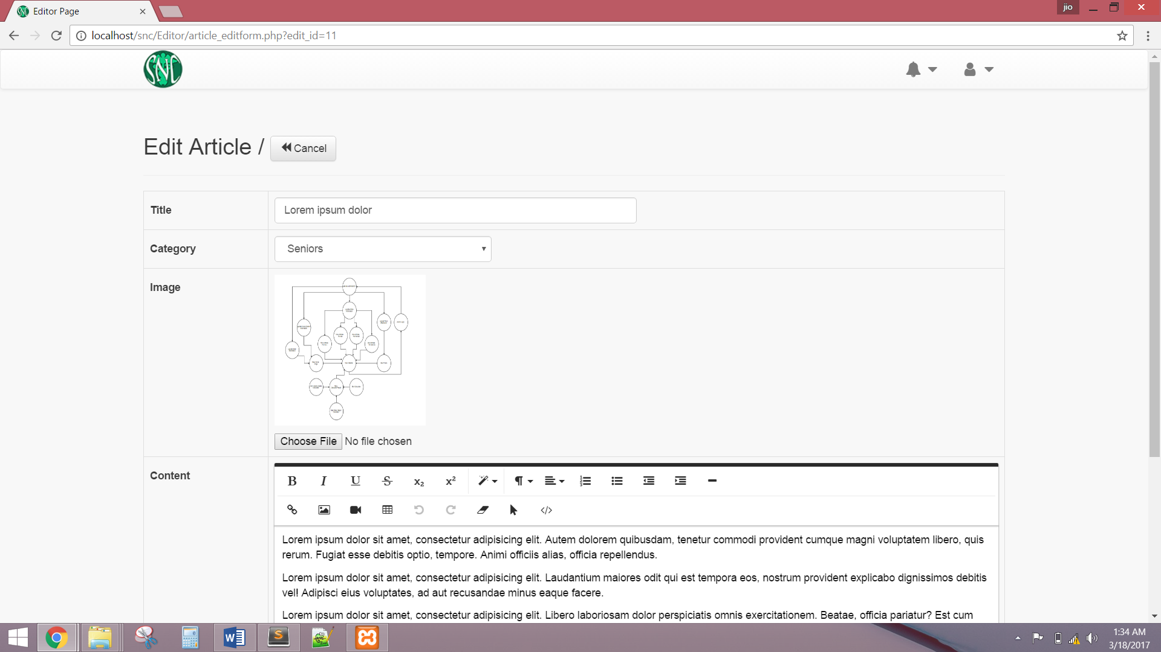

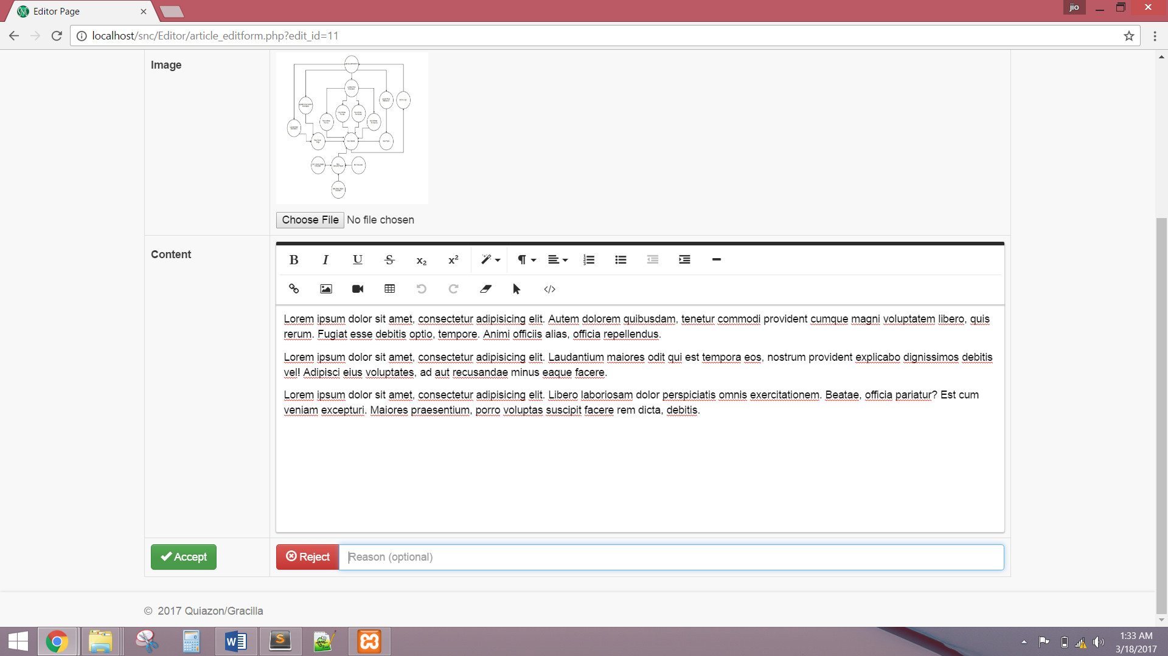

The system shall display the Publisher account after a successful login. The system shall allow the Publisher to manage account by updating profile, or changing password.

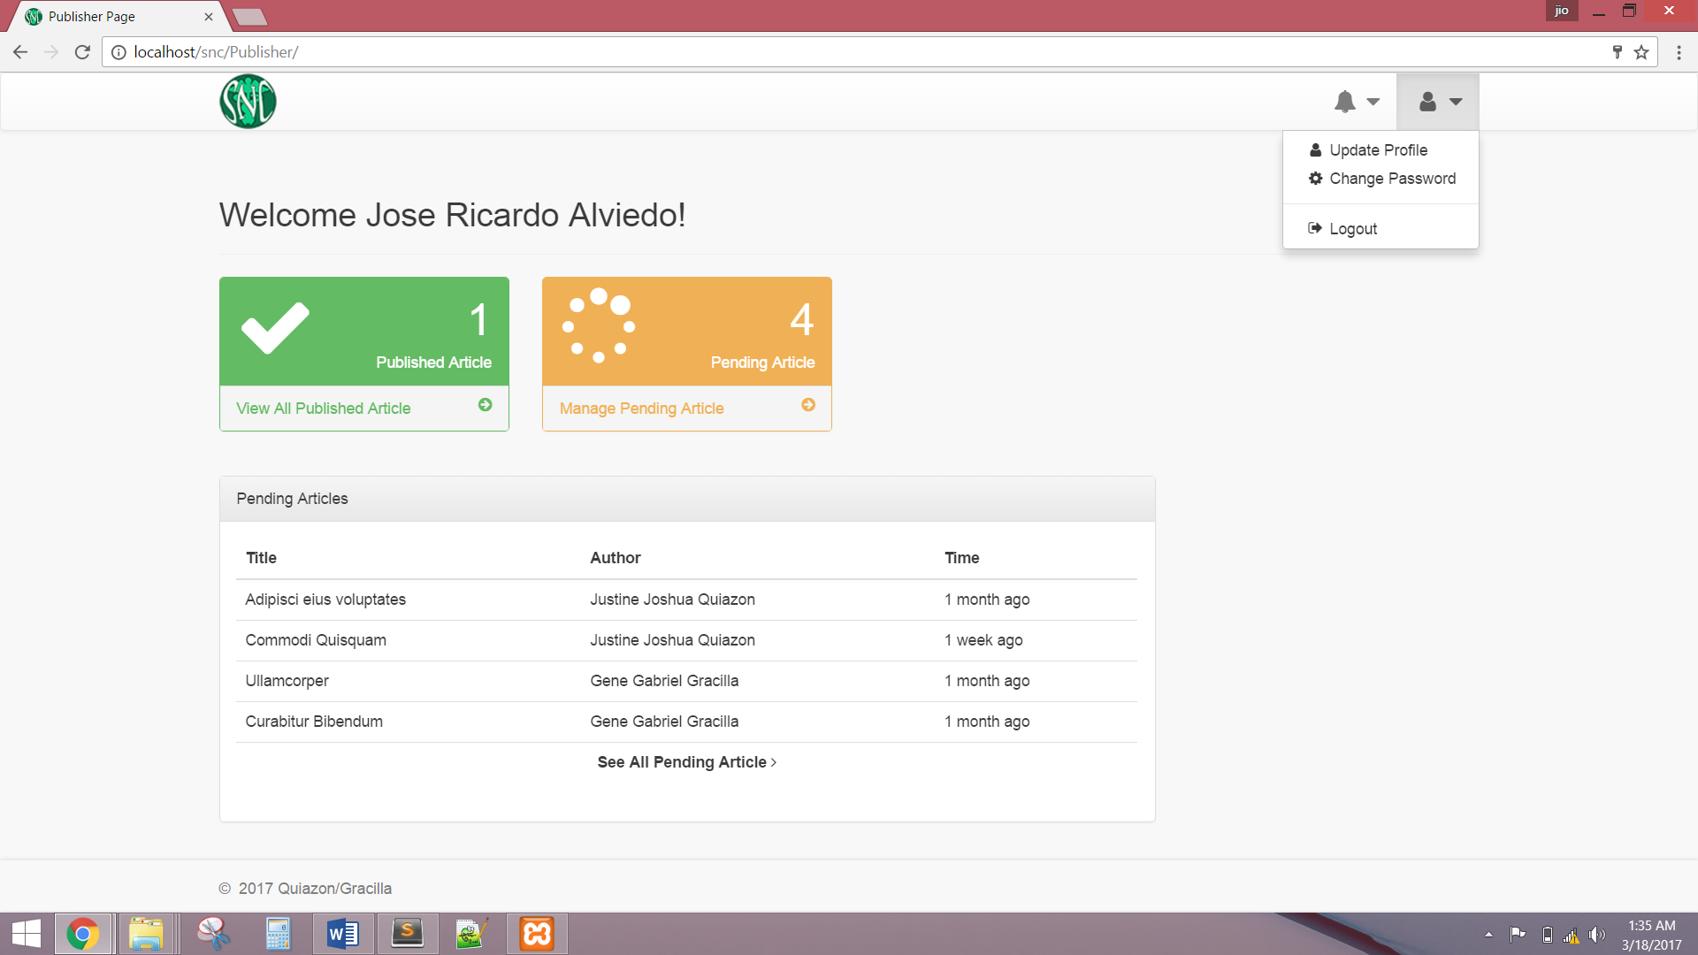

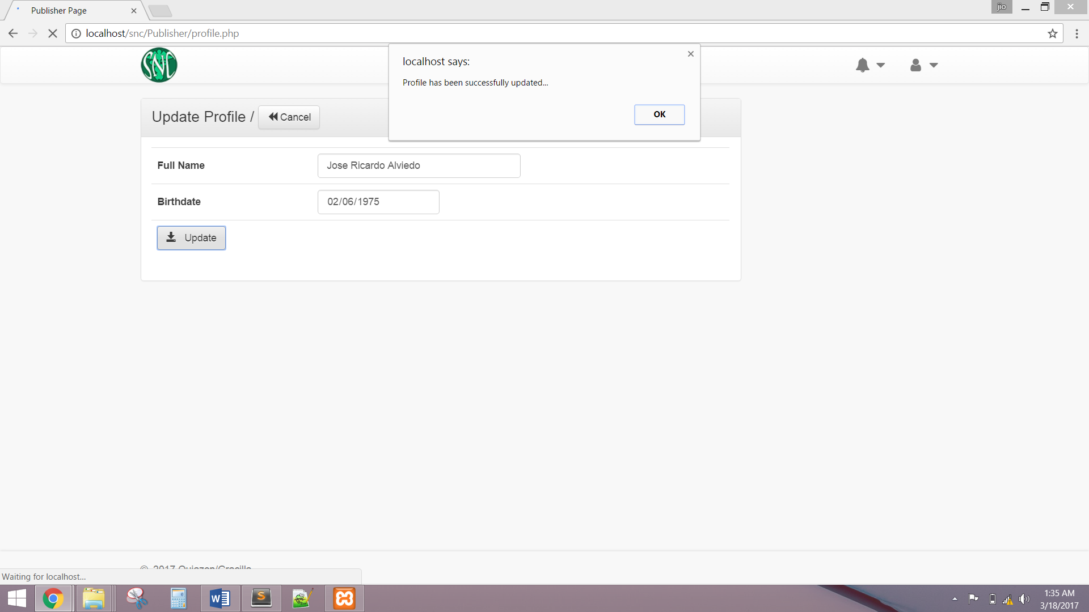

The system shall allow Publisher to view all articles that have been accepted/edited by Editor.

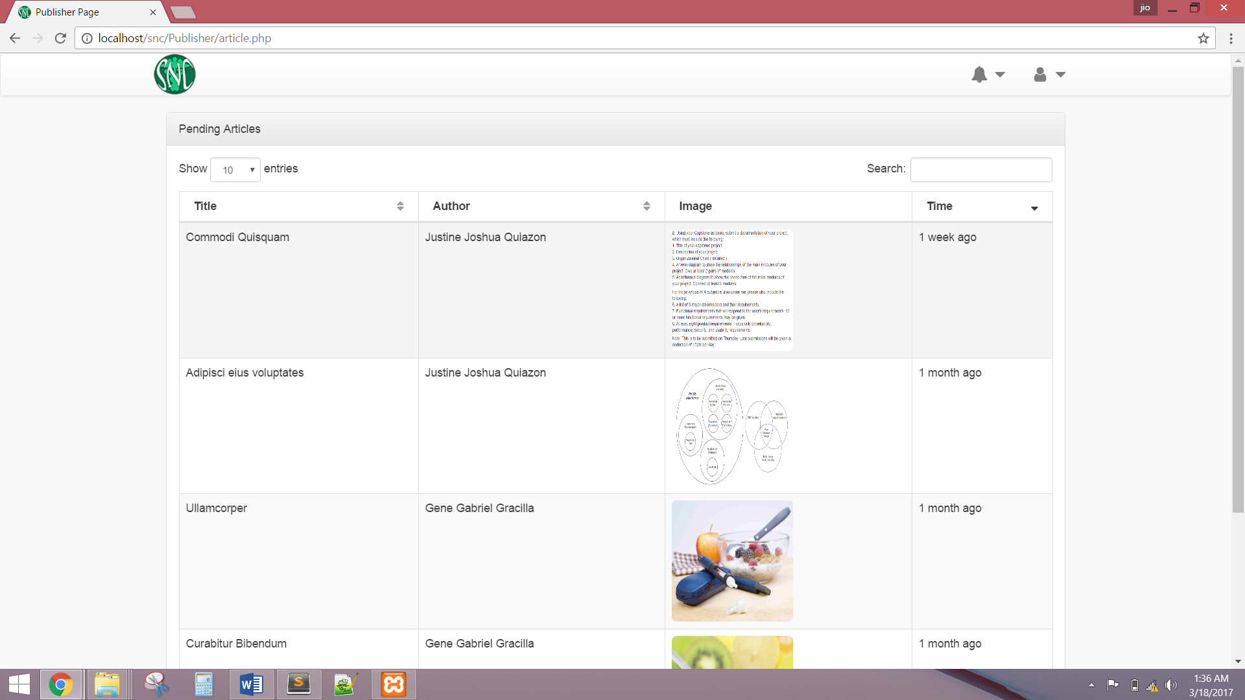

The system shall allow Publisher to accept or reject an article.

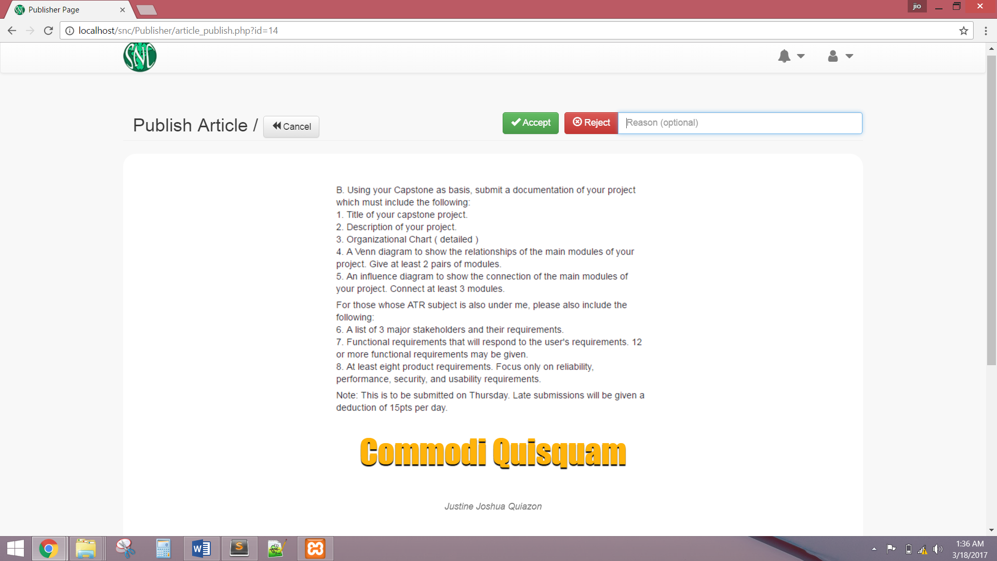

The system shall display the Manager account after a successful login. The system shall allow the Manager to view the dashboard of current articles and food of the website.

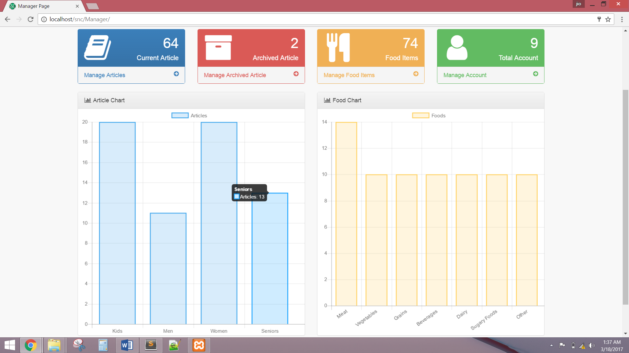

The system shall allow Manager to view and manage all articles.

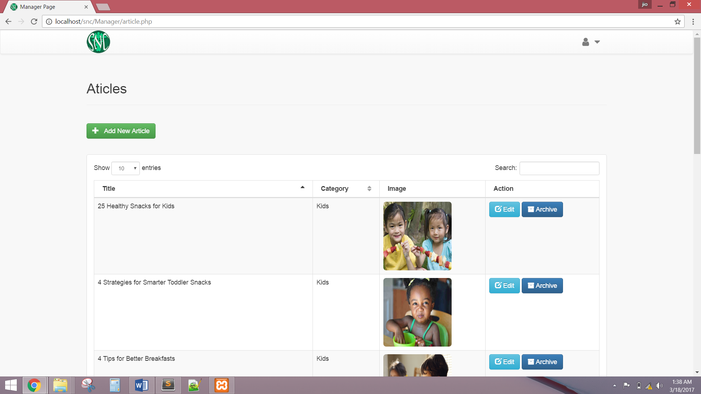

The system shall allow Manager to add new article and must have a validation rule.

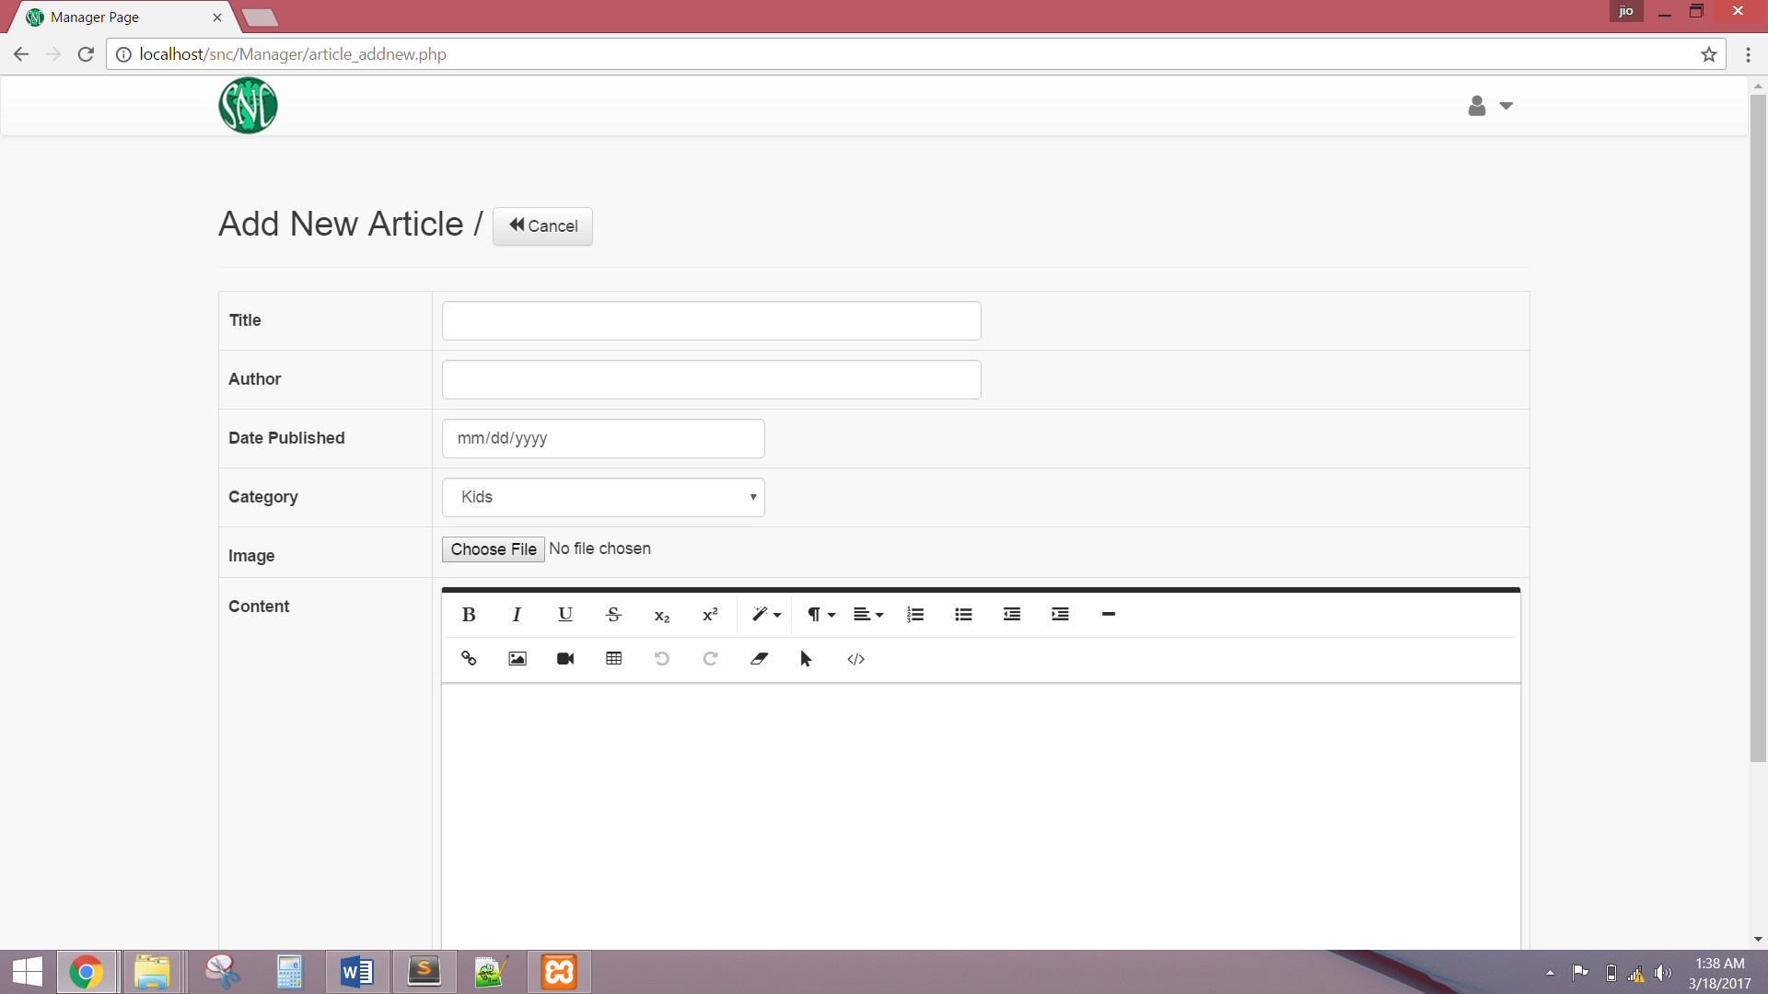

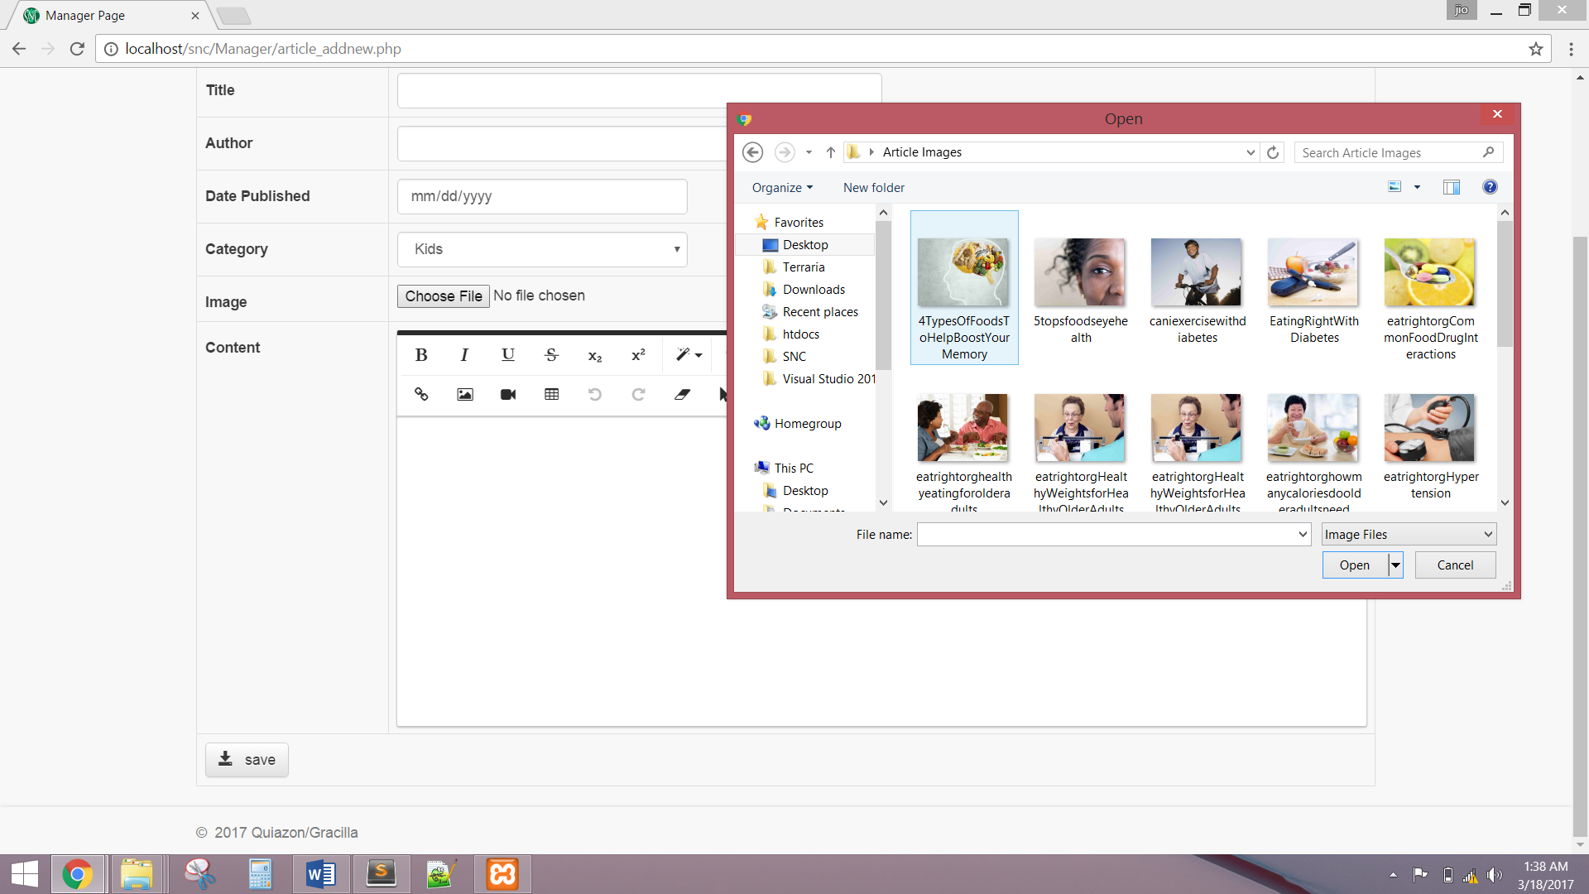

The system shall allow Manager to edit current articles.

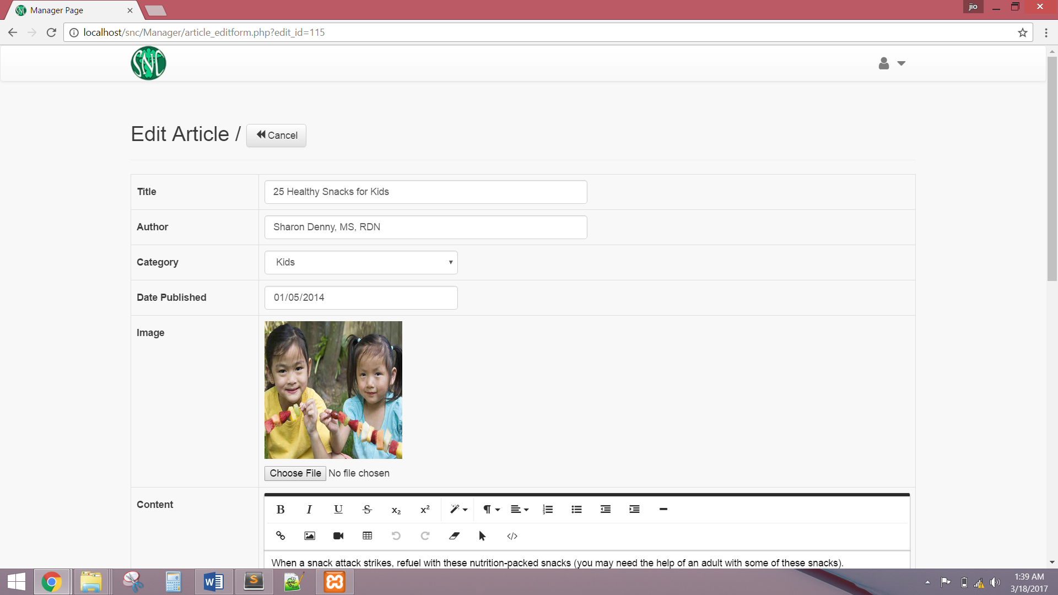

The system shall allow Manager to archive an article.

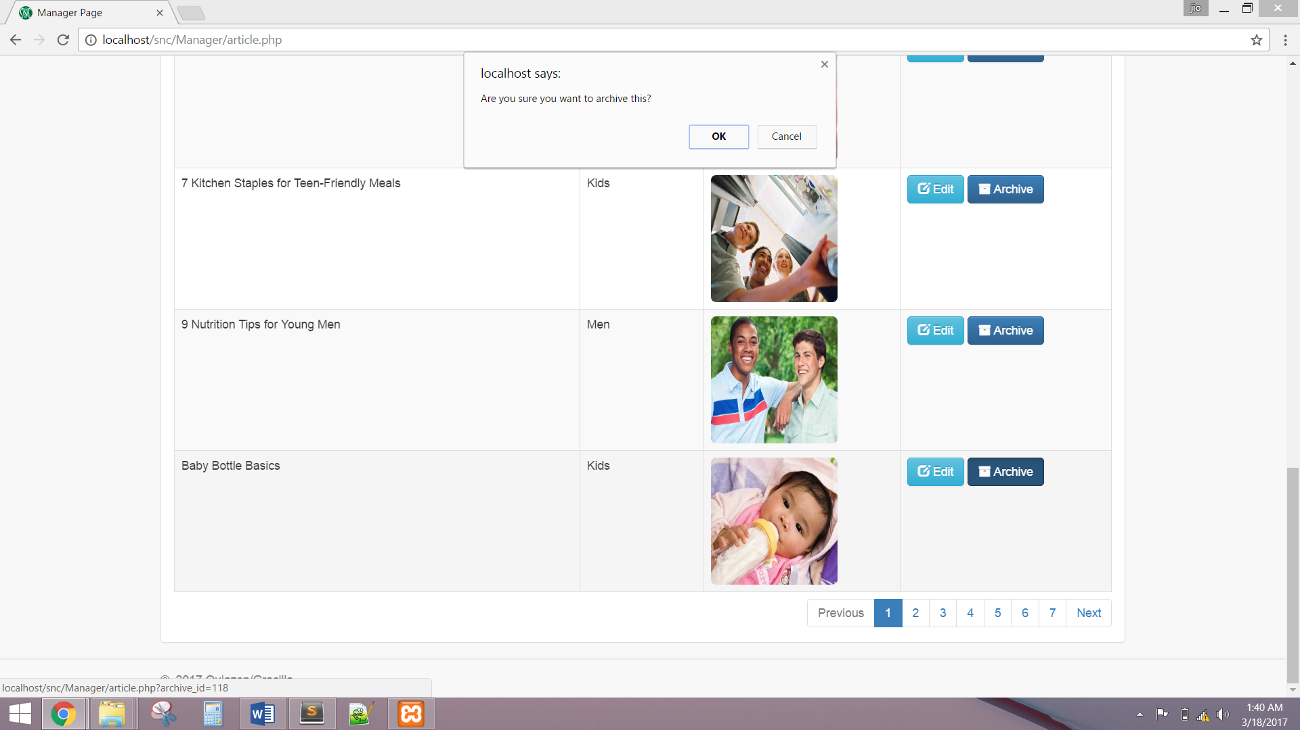

The system shall allow Manager to manage all archived articles.

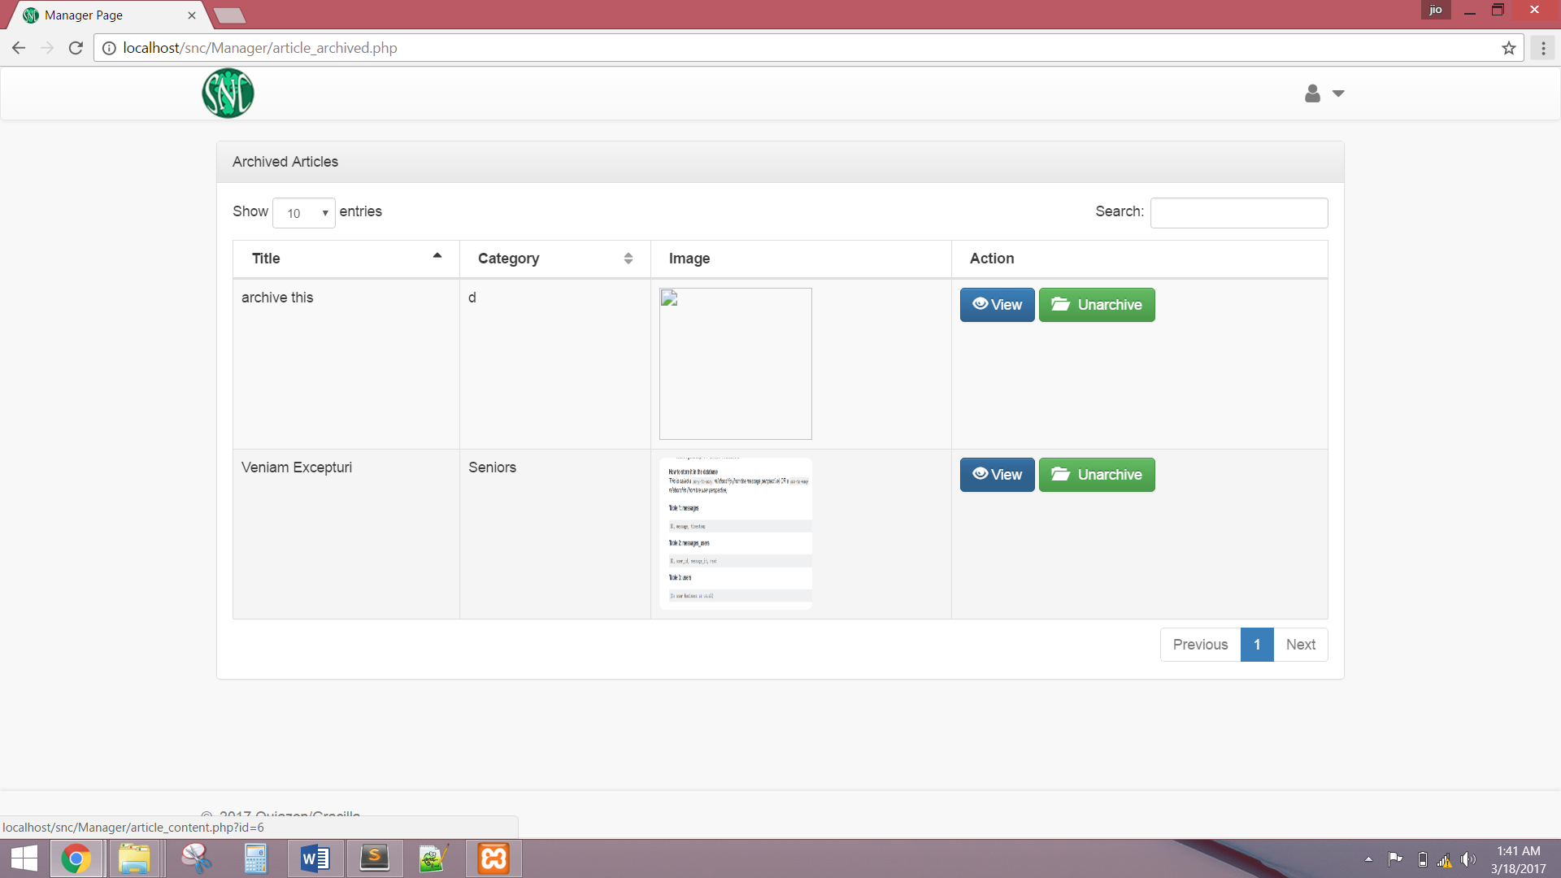

The system shall allow Manager to view and manage all foods in website.

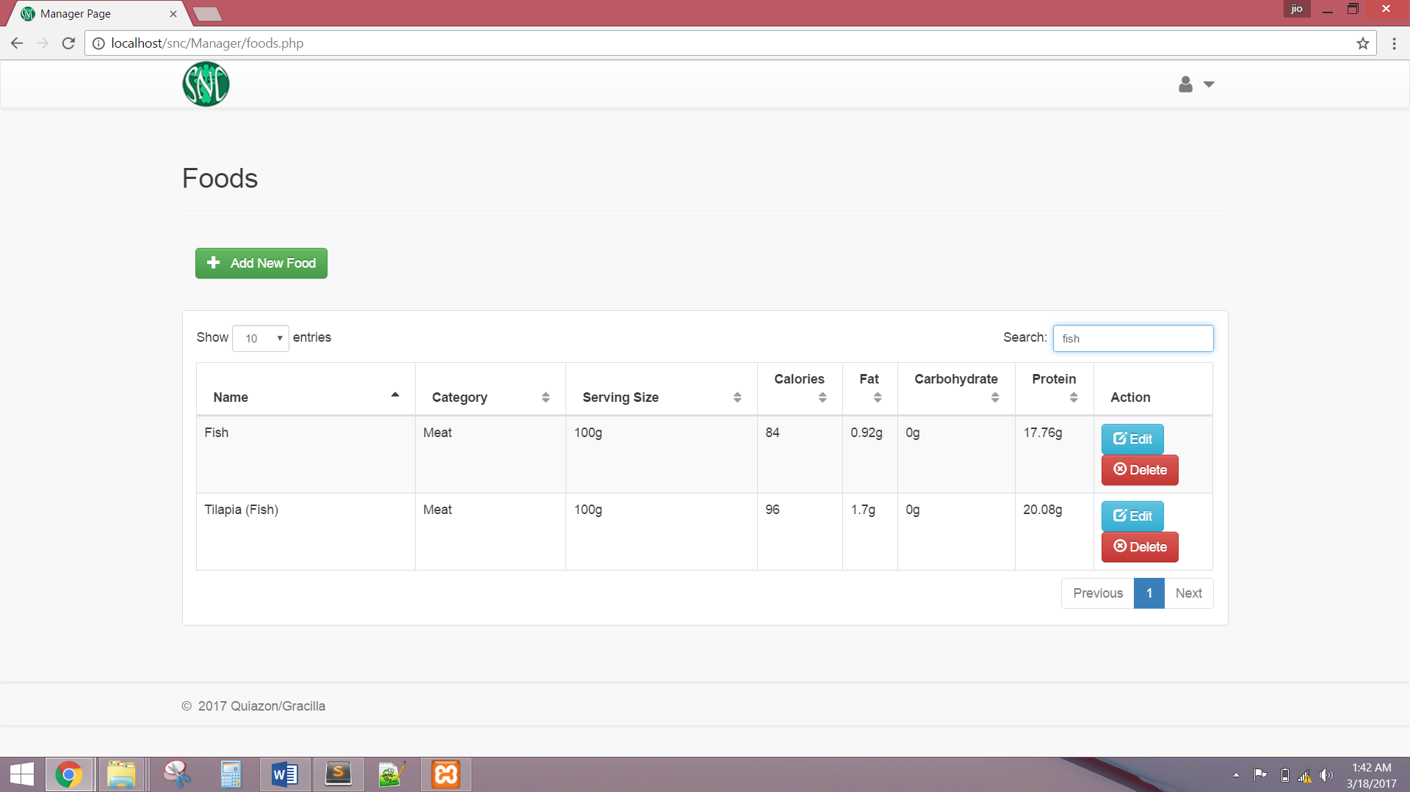

The system shall allow Manager to add new food and must have a validation rule.

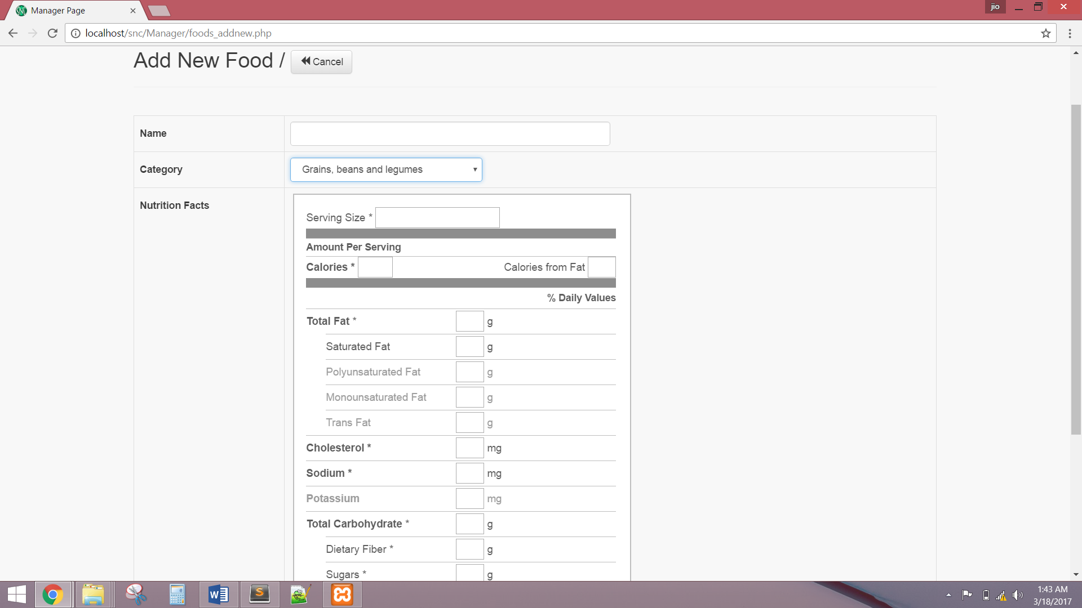

The system shall allow Manager to edit current food.

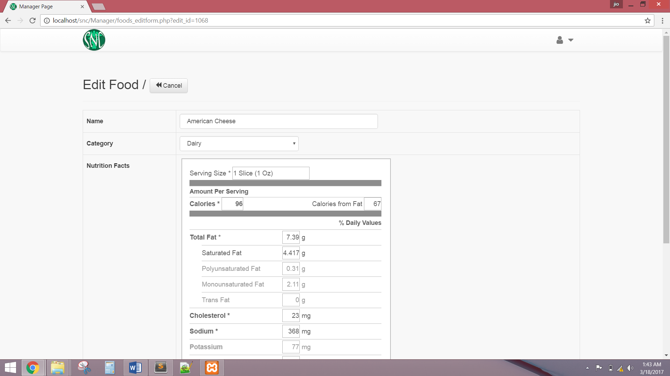

The system shall display the Administrator account after a successful login. The system shall allow the Administrator to manage account by updating email, or changing password.

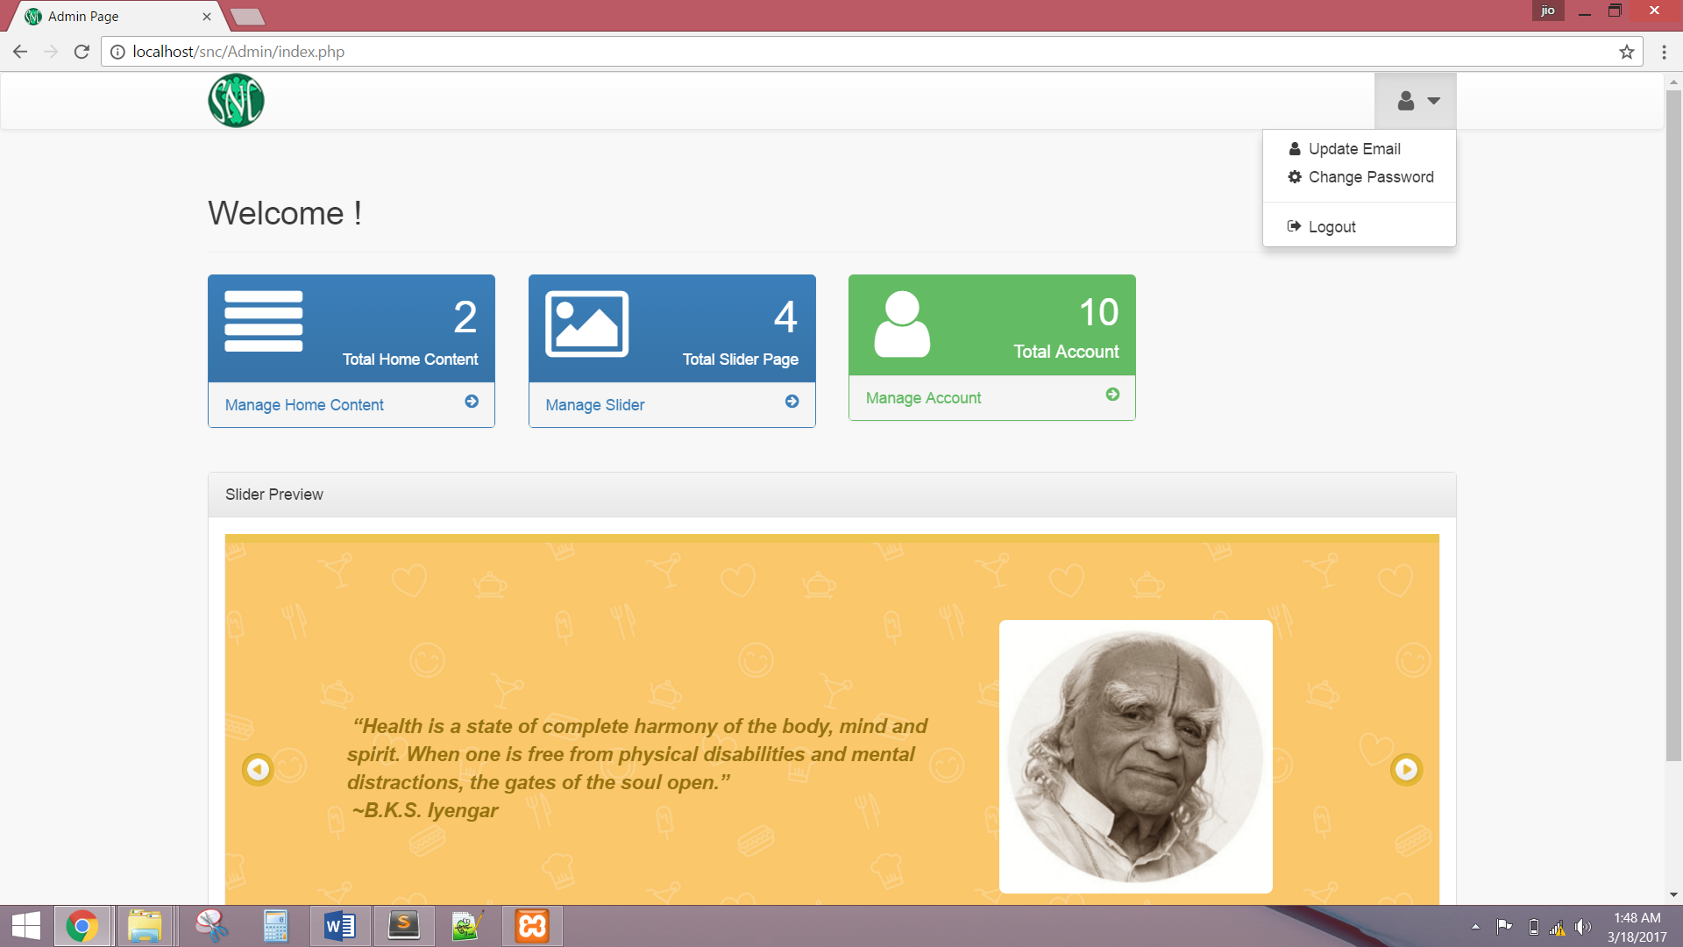

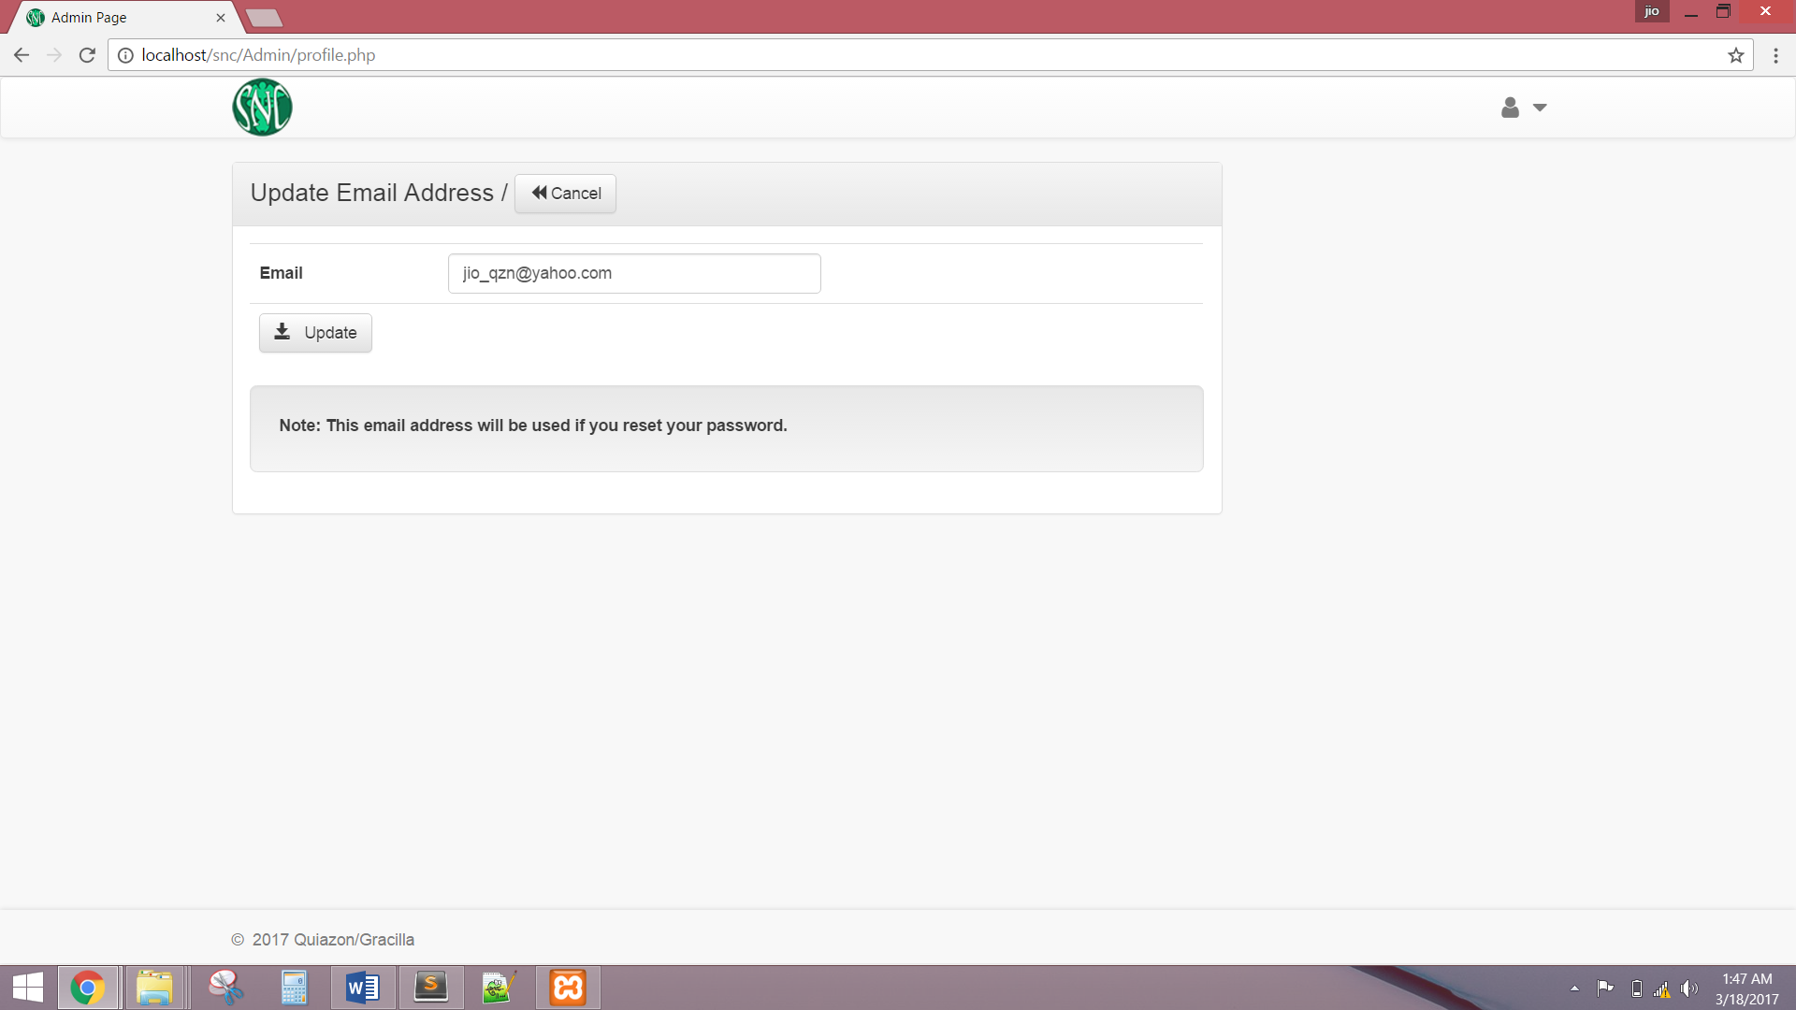

The system shall allow Administrator to view and manage all home page content.

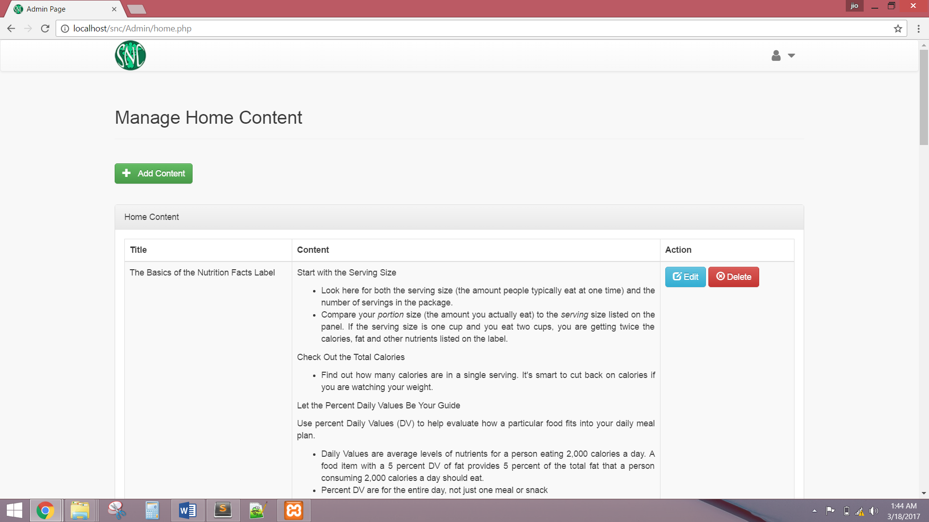

The system shall allow Administrator to add new home page content and must have a validation rule.

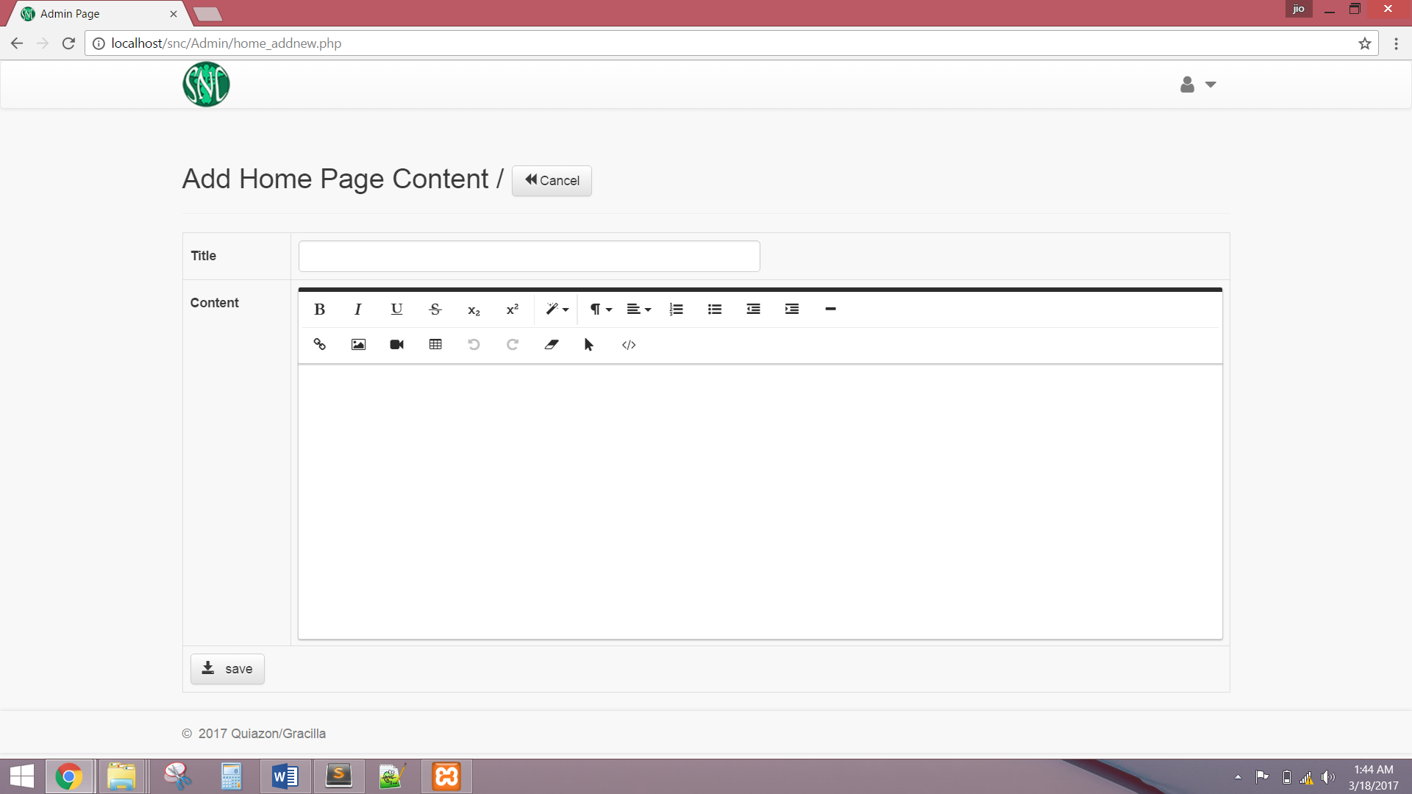

The system shall allow Administrator to edit current home content.

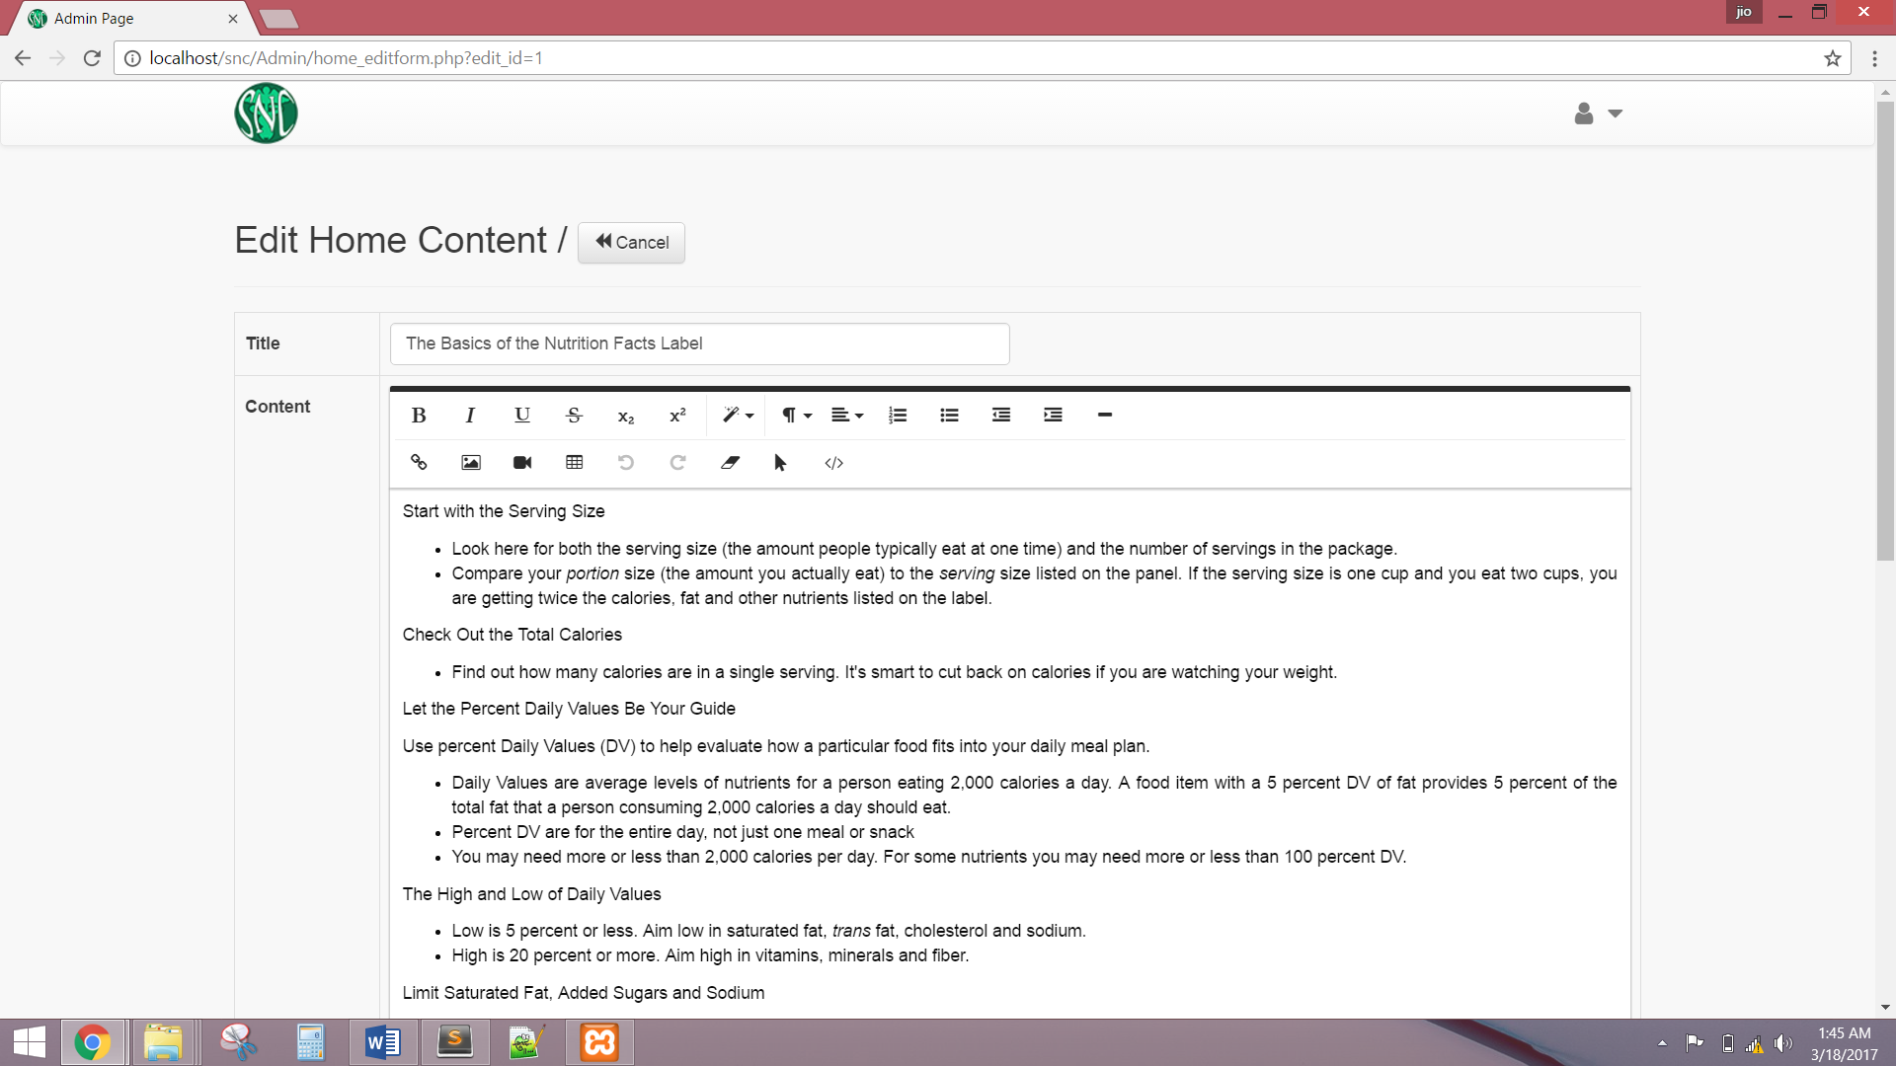

The system shall allow Administrator to view and manage all content of the slider.

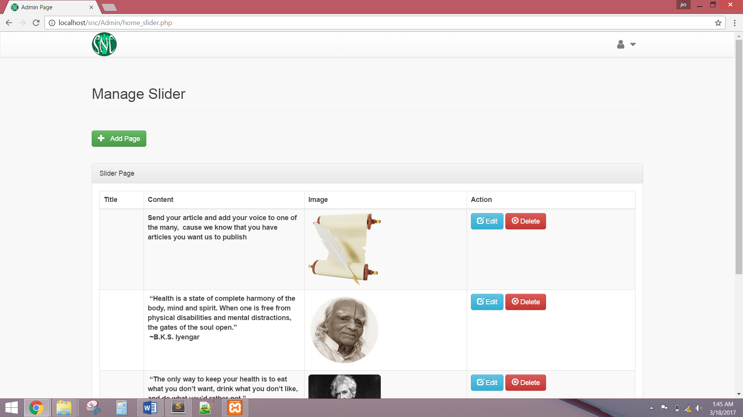

The system shall allow Administrator to add new slider page.

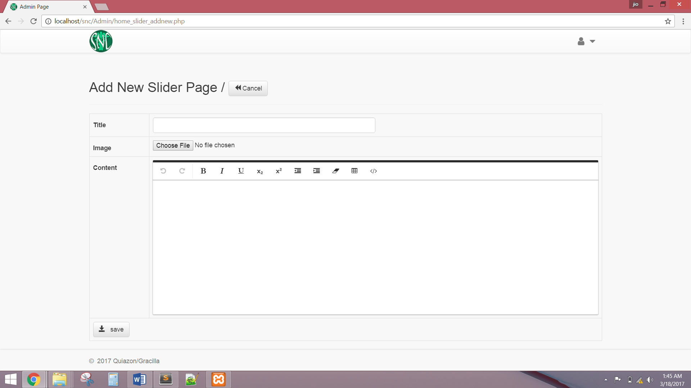

The system shall allow Administrator to edit current slider page.

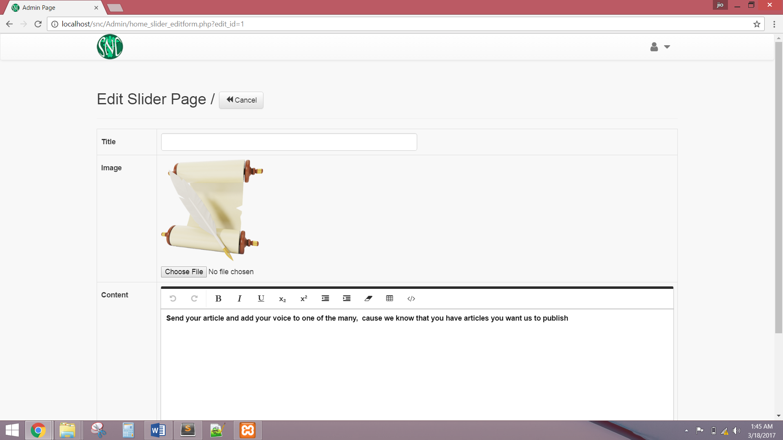

The system shall allow Administrator to manage all accounts of Manager, Publisher, Editor, & Writer. The system shall also allow Administrator to add new Editor, Publisher or Manager Account.

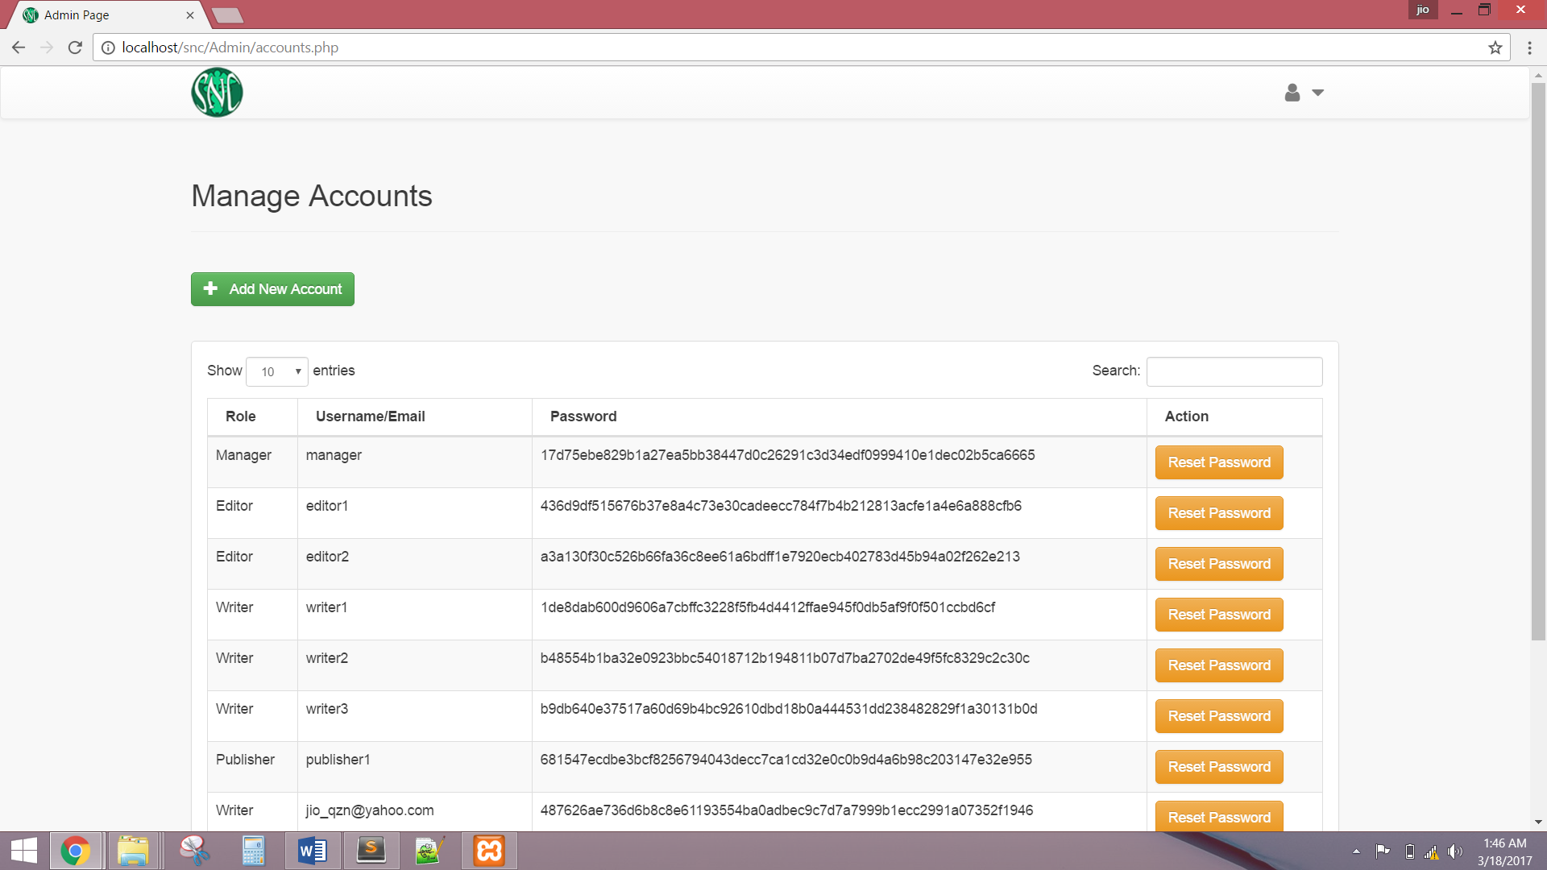

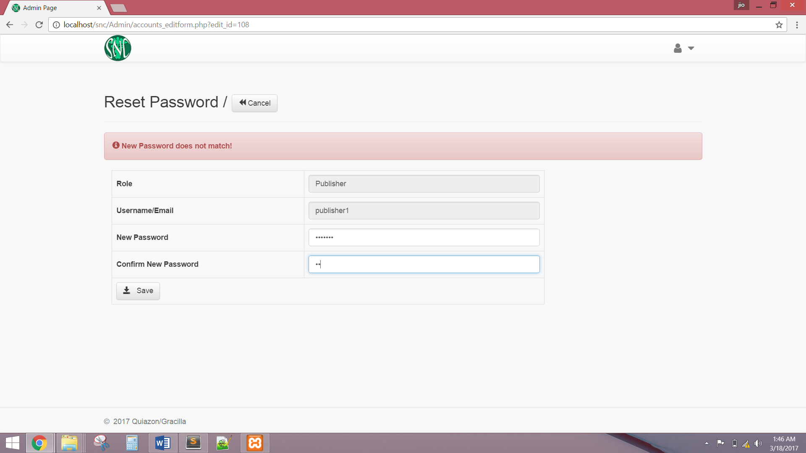

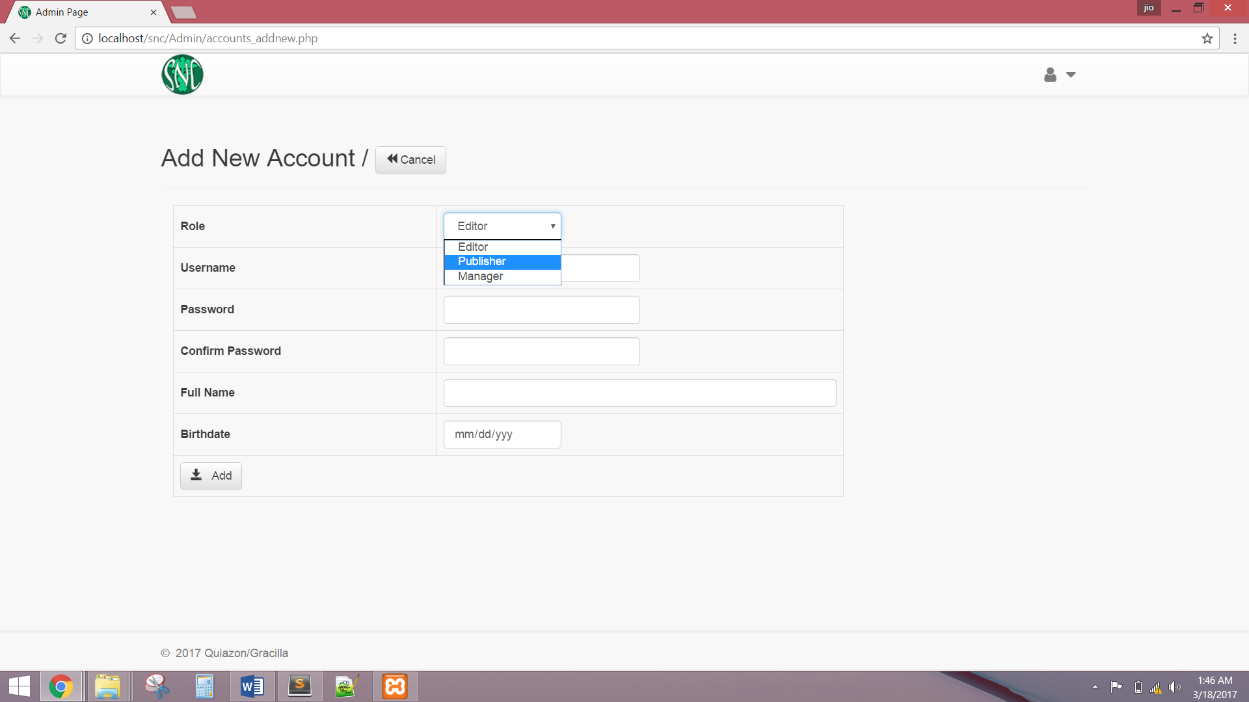

The Administrators shall be able to reset password through email address associated with the username.

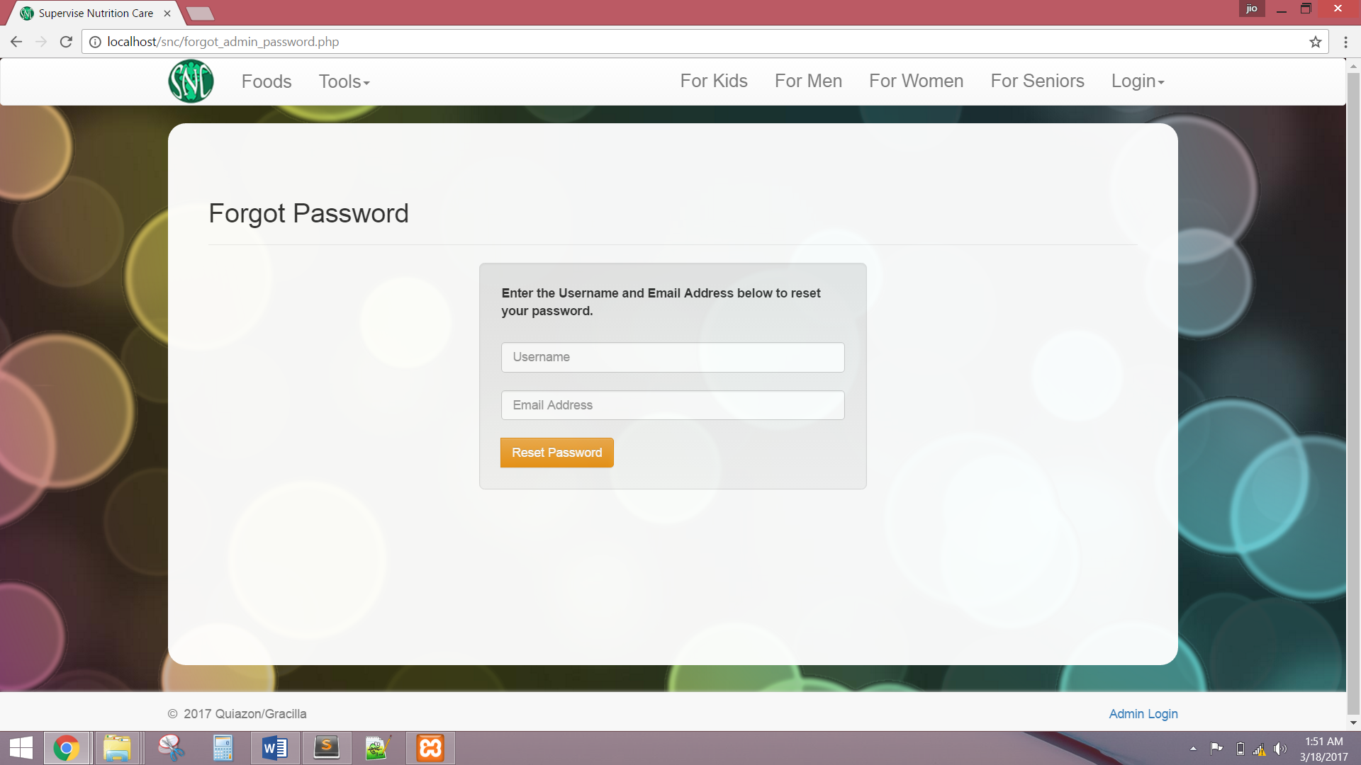

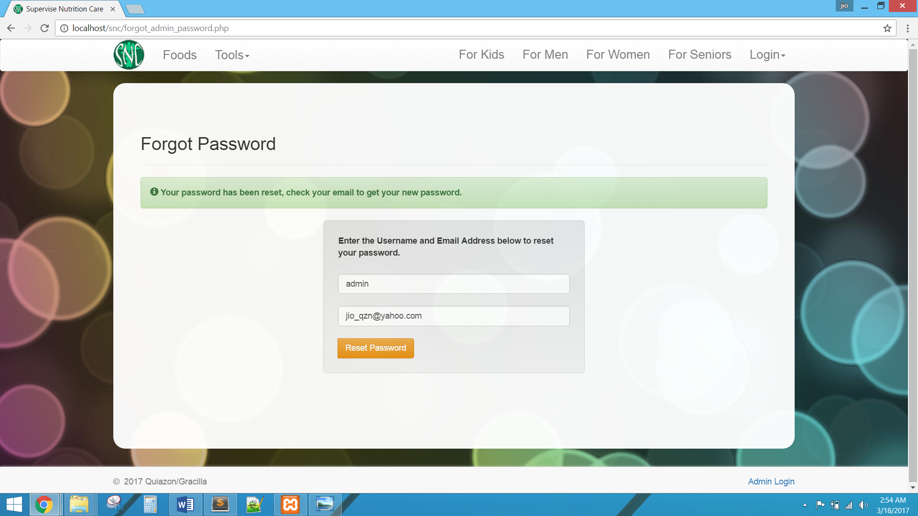

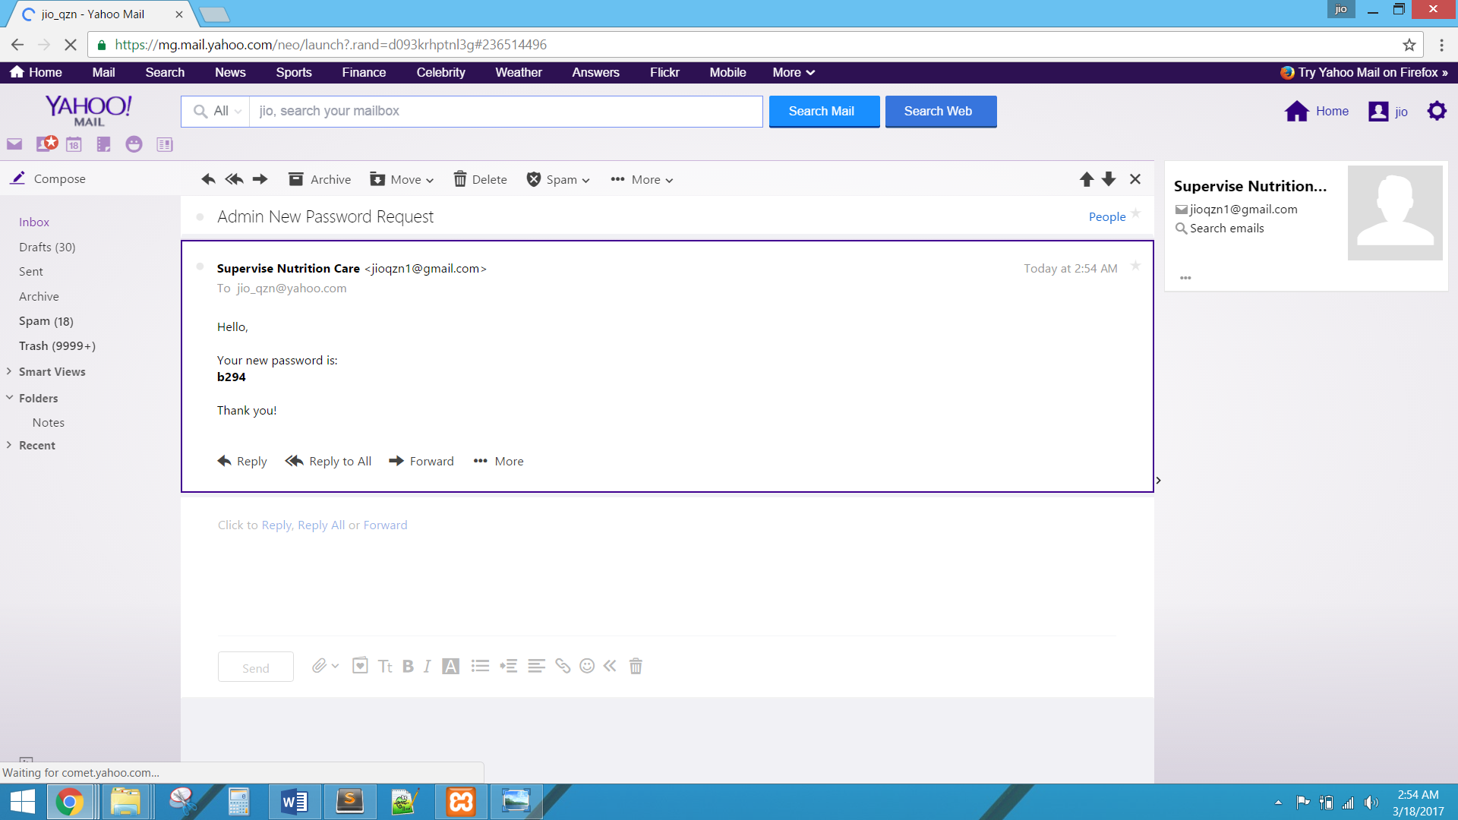

The system must disable the admin login for 10 minutes after three consecutive unsuccessful login attempts.

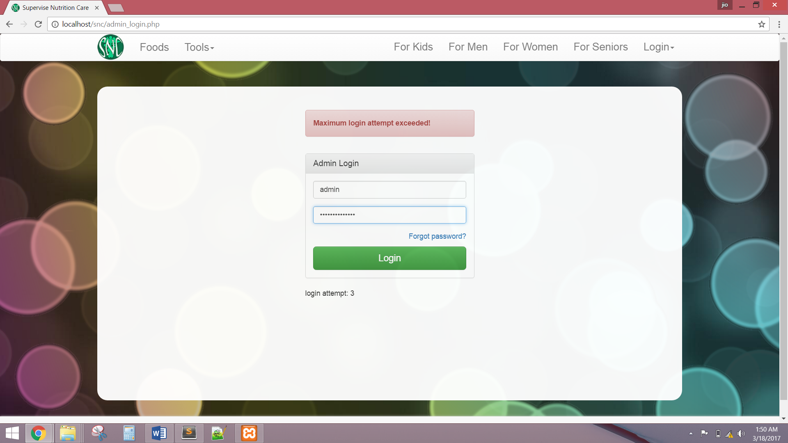

USE CASE DIAGRAM